**Evolutionary Analysis and Host State Reconstruction of Rust Fungi (Pucciniales; Basidiomycota),**

**with Emphasis on the Morpho-Molecular Characterization of Coffee Rust (*Hemileia vastatrix*) in**

**Sri Lanka.**

U.S.R. Isanka

Dissertation submitted to the Department of Plant and Molecular Biology, University of Kelaniya, Sri Lanka, as a partial fulfillment of the requirements for the B.Sc (Honours) degree in Molecular Biology and Plant Biotechnology

February, 2025

## DECLARATION

The work reported in this dissertation is the result of the candidate’s own investigation carried out at the Department of Plant and Molecular Biology, University of Kelaniya, Sri Lanka. it has not been submitted concurrently in candidature for any other degree.

Date Ms. U.S.R. Isanka

I certify that the above statement is correct.

Prof. D.A. Daranagama Professor,

Department of Plant and Molecular Biology, University of Kelaniya,

Sri Lanka.

Name of the student : Ms. U.S.R. Isanka

Name of the supervisor : Prof. D.A. Daranagama

Signature of the supervisor :

Name of the head of the department : Prof. R.M.C.S. Rathnayake

Signature of the head of the department :

**CONTENTS**

**LIST OF TABLES**…………………………………………………………………………………6

**LIST OF FIGURES**…………………………………………………………………………… …7

**LIST OF ABBREVIATIONS**…………………………………………………………………….8

**ACKNOLEDGEMENT**…………………………………………………………………………..9

**ABSTRACT**……………………………………………………………………………………….10

1.0 **INTRODUCTION** 12

1.0 Background 12

1.1 Specific Objectives: 14

1.2 Hypothesis: 14

2.0 **LITERATURE REVEIW** 15

2.1 Overview of Rust Fungi (Pucciniales; Basidiomycota) 15

2.1.1Taxonomic classification 15

2.1.2. General characteristics and life cycle 17

2.2 Importance of Studying Rust Fungi 19

2.2.1 Economic and agricultural impact 19

2.2.2 Ecological significance 20

2.3 Evolutionary Analysis of Rust Fungi 21

2.3.1 Phylogenetic Studies 21

2.3.1.1 Overview of phylogenetic methods………………………………………………….21

2.3.2.2 Key Insights into the Phylogeny of Rust Fungi……………………………………...23

2.3.2 Evolutionary History 24

2.3.2.1 Evolutionary Relationships within Pucciniales……………………………………...24

2.3.2.2 Genetic Markers in Evolutionary Studies……………………………………………25

2.3.3 Evolution of Host Specificity 26

2.3.3.1 Mechanisms of host adaptation…………………………………………………….. 26

2.3.3.2 Examples of host shifts and co-evolution……………………………………………28

2.4 Rust Fungi on Coffee 29

2.5 Coffee Rust Fungi in Sri Lanka 32

3.0 **METHODOLOGY** 35

3.1 Sample collection 35

3.2 Isolation of fungal spores from diseased leaf sample 35

3.3 Morphological characterization 35

3.4 DNA extraction, PCR, Sequencing 36

3.5 Data collection and phylogenetic analysis 37

3.6 Divergence time analysis and Ancestral state reconstruction 38

4.0 **RESULTS** 40

4.1 Sample Collection 40

4.1.1 Study sites 40

4.1.2 Symptoms of Infection 40

4.2 Spore Morphology of *Hemileia vastatrix* 41

TAXONOMY 44

4.2.1 *Hemileia vastatrix* from Balangoda Site 44

4.2.2 *Hemileia vastatrix* from Matale Site 47

4.3 Phylogenetic analysis 49

4.4 Divergence time analysis 54

5.0 **DISCUSSION** 62

6.0 **RECOMMENDATIONS** 71

7.0 **REFERENCES**…………………………………………………………………………….........73

APPENDICES 86

Appendix 1 86

Appendix 2…………………………………………………………………………………………87

**Table 4.1**: Comparative Analysis of Environmental Conditions, Symptomatology, Urediniospore and Morphological Characteristics of Hemileia vastatrix Collected from Matale (Central Province) and Balangoda (Sabaragamuwa Province) in SriLanka 43

**Fig 2.1:** Typical life cycle of some rust fungi, such as *Puccinia graminis* 18

**Fig 4.1**: Coffee rust infected leaves with characteristic symptom 41

**Fig 4.2:** Carotenoid lipid granules observed in urediniospores 42

**Fig 4.3**: Symptoms and morphology of coffee leaf rust, *Hemileia vastatrix* collected from Balangoda District, Sabaragamuwa Province, Sri Lanka 46

**Fig 4.4**: Symptoms and morphology of coffee leaf rust, *Hemileia vastatrix* collected from Matale District, Central Province, Sri Lanka………………………………………………………. 48

**Fig 4.5** - Phylogram resulted from combined LSU, SSU and COX3 specices of order Pucciniales using maximum likelihood method……………………………………………………………...49

**Fig 4.6** – Divergence time estimation of order Pucciniales using BEAST v1.10.4 programme based on multi-gene loci data and considering secondary calibration nodes analysis ..54

.

|  |  |
| --- | --- |
| BEAST | Bayesian Evolutionary Analysis Sampling Trees |
| °C | Degree Celsius |
| cm | Centimeter |
| Cox3 | Cytochrome c oxidase subunit 3 |
| g | Gram |
| ha | Hectare |
| ITS | Internal Transcribe Spacer |
| Kg. | Kilogram |
| LSU | Large Sub Unit |
| m. | Meter |
| ml | Milliters |
| MEGA | Molecular Evolutionary Genetics Analysis |
| MUSCLE | Multiple Sequence Comparison by Log-Expectation |
| MYA | Million Years Ago |
| mm | Millimeter |
| Ma | Millions Ago |
| NCBI | National Center for Biotechnology Information |
| PCR | Polymerase Chain Reaction |
| RaxML | Randomized Axelerated Maximum Likelihood |
| RASP | Runtime Application Self-Protection |
| rDNA | Ribosomal Deoxyrhybo Nucleic Acid |
| $. | Dollar |
| SSU | Small Sub Unit |
| tMRCA | time to Most Recent Common Ancestor |
| µl | Microliter |
| µm | Micrometer |

First and foremost, I would like to express my deepest gratitude to my supervisor, Professor Anupama Daranagama, for her invaluable guidance, continuous support, and encouragement throughout this research. Her expertise and enthusiasm have been instrumental in the successful completion of my study. I extend my heartfelt appreciation to my co-supervisor, Dr. Millan C. Samarakoon, for his insightful advice, patience, and technical support, which have played a significant role in shaping this research journey.

I am also immensely grateful to Professor R.M.C.S. Rathnayaka, Head of the Department of Plant and Molecular Biology, as well as all the academic and non-academic staff of the department, for their unwavering support and assistance in facilitating my research work.

A special note of appreciation goes to the Chairperson and all the academic staff of the Central Export Agricultural Research Center, Matale, for their generous support in the collection of samples and for providing me with essential information related to my research.

Furthermore, I am deeply thankful to my seniors, especially Lakshi Wijayarathna, for their continuous encouragement and willingness to help whenever needed. Their guidance has been immensely beneficial in navigating the challenges of this research.

Last but certainly not least, I am profoundly grateful to my parents, siblings, and colleagues for their unwavering love, patience, and support. Their belief in me has been my greatest source of strength throughout this journey, and I deeply appreciate their encouragement and motivation

To all those who have contributed in various ways to the successful completion of my research, I extend my heartfelt thanks and appreciation.

The rust fungi represent the most complex and economically important phytopathogens in the Basidiomycota, including more than 7,800 described species with a wide distribution on crops worldwide. The causal agent of coffee leaf rust, *Hemileia vastatrix*, has, since the first outbreak in Sri Lanka during the 19th century, continuously posed serious threats to cultivation with devastating impacts. Despite its importance, little is known about the evolutionary analysis of the order Pucciniales and the morpho-molecular characterization of *H. vastatrix* using Sri Lankan samples. Thus, the present study focuses on the morpho-molecular variations in *H. vastatrix* and the reconstruction of ancestral host traits in Pucciniales to trace evidence of significant events in its evolutionary history. The samples of infected leaves with coffee rust were collected from Matale and Balangoda districts of Sri Lanka. Microscopic observation was done for urediniospores concerning their shape, size, and wall ornamentation. ; the molecular data analysis included DNA extraction and PCR amplification of LSU, and SSU regions, followed by reconstruction of a phylogenetic tree through ML analysis was carried out using pathogen-specific primers. Bayesian analysis was applied to estimate divergence time in the BEAST Program. The ellipsoidal shape, thick-walled urediniospores, and echinulation patterns of urediniospores were confirmed through morphological analysis. Morphologically, no significant variation was recorded between the Matale and Balangoda samples. Phylogenetic analysis has given evidence of the evolutionary relationship among species of 18 families of the order Pucciniales and verified the position of *H. vastatrix* within the family Zaghouaniaceae. Divergence time estimates for Pucciniales place it at ca. 163 million years ago, during the rise of angiosperms, thereby providing strong evidence to the co-evolution hypothesis of rust fungi with their host plants. The Zaghouaniaceae family, including *H. vastatrix*, diverged ~132 million years ago during the early Cretaceous when several angiosperm groups are considered to have had significant diversifications. The estimated

divergence time for *H. vastatrix* was approximately 107 million years later, indicating its recent adaptation to Coffea species. These results are another piece of strong evidence in favor of the evolutionary history of rust fungi and their host plants concerning host jumps and co-evolutional processes responsible for Pucciniales diversity.

# 1.0 INTRODUCTION

## 1.0 Background

The Pucciniales order, also known as "Rust Fungi," represents the most complex group of phytopathogens within the Basidiomycota, comprising over 7,800 identified species worldwide (Zhao *et al*., 2021; Aime *et al*., 2006). The complex life cycles of these obligate parasitic fungi involve five distinct spore types: basidiospores, spermatia, aeciospores, urediniospores, and teliospores (Zhao *et al*., 2021). Morphological differences between spores can be used to identify various genera of rust fungi. These differences include the number of cells in the teliospores, the number of germ pores per cell, teliospore germination, the presence or absence of paraphyses in the sorus, the persistence of pedicels, spore ornamentation and staining, and the presence or absence of uredinia (Cruz *et al*., 2015). Rust fungi exhibit diverse life cycle patterns microcyclic, hemicyclic, demicyclic, and macrocyclic based on the number of spore stages they possess. This variety enhances their complexity and adaptability. As pathogens, some rust fungi species complete their entire life cycle on a single host (autoecious), while others require two unrelated hosts (heteroecious) to complete their life cycle, adding another layer of complexity (Zhao *et al.,* 2023). The two unique phases of the heteroecious life cycle of rust fungi are the aecial and telial stages/hosts, each of which occurs on a different host. Due to their versatility, many species of rust fungi infect a wide range of agricultural and forest crops, leading to significant economic losses. Moreover, these diseases tend to spread rapidly, posing a serious problem in the field of plant pathology. (Zhao *et al*., 2023; Aime *et al*., 2018).

Coffee leaf rust (CLR) disease) was the first rust disease to appear in Sri Lanka during the 19th century and has been a major risk to Arabica coffee (*Coffea arabica*) cultivation for more than a century (Silva *et al*., 2012). After the initial outbreak in 1869 in Sri Lanka, CLR quickly expanded to other coffee-

growing regions, devastating the coffee industry in Sri Lanka and forcing a shift to tea cultivation (Koutouleas *et al*., 2024). CLR is caused by the biotrophic fungus *Hemileia vastatrix,* which is a biotrophic fungus, meaning it requires a living host to survive and reproduce. Three of the five rust- related spore types are produced by *H. vastatrix:* urediniospores, teliospores, and basidiospores and no alternative host has been discovered for these spores. When coffee plants are infected with this fungus, photosynthesis is decreased, resulting in defoliation, lower yields, and maybe even plant death if not controlled (Koutouleas *et al*., 2024).

The evolution of the Pucciniales order, which includes rust fungi, remains a complex and multifaceted problem in the fields of plant pathology and evolutionary biology. Despite considerable advances in recent years, several evolutionary questions persist regarding the evolution of Pucciniales and the adaptations that enabled them to become the largest and most complex group of plant pathogens. (Aime *et al*., 2017). For example, the complex heteroecious life cycle of rust fungi has led to several hypotheses about how the coevolution between the fungi and their hosts has driven the diversification of the Pucciniales order. However, there have been no studies that have directly tested these hypotheses about the coevolutionary processes shaping the diversity of rust fungi (Aime *et al*., 2018).

Although coffee is attacked by several other harmful diseases and pests, such as coffee wilt disease and coffee berry disease, those diseases are confined to Africa, and their damaging financial and social impact is less global than that of CRL (Koutouleas *et al*., 2024). Therefore, understanding the evolutionary history of coffee rust fungi is key to developing successful methods for dealing with the coffee leaf rust diseases they cause. Through morpho-molecular characterization and host state reconstruction, we can obtain important information regarding the pathogen's adaptation to various coffee varieties and environmental factors. The divergence time estimation is useful to determine the evolutionary timeline for the rust fungi, to date key speciation events with a molecular clock, and the

divergence dates of coffee rust fungi have never been studied with a molecular clock calibrated to definitive points in time (McTaggart *et al.,* 2016).

## 1.1 Specific Objectives:

* + - To characterize the morpho-molecular variations of coffee rust (*Hemileia vastatrix*) in Sri Lanka.
    - To map and analyze the ancestral host trait within the Pucciniales order, identifying key evolutionary milestones.

## 1.2 Hypothesis:

* + - There exists a significant morpho-molecular variation of coffee rust (*Hemileia vastatrix*) in Sri Lanka.
    - Host ancestral state reconstructions within the Pucciniales order unveil notable transitions in host specificity and jumping events throughout their evolutionary history.

# 2.0 LITERATURE REVEIW

## 2.1 Overview of Rust Fungi (Pucciniales; Basidiomycota)

### 2.1.1Taxonomic classification

A widespread and extensively dispersed group of plant diseases, rust fungi (order Pucciniales) are categorized under the class Pucciniomycetes and the division Basidiomycota. They have tight phylogenetic ties to other fungal orders, including Septobasidiales, Pachnocybales, Helicobasidiales, and Platygloeales. Rust fungi are one of the largest fungal orders in the kingdom Fungi, with around 7,000 species (Aime *et al*., 2006; Avasthi *et al*., 2023).

In the past, the morphology of basidia and the structural traits of teliospores were used to divide rust fungi into three or four families: the Pucciniaceae, Melampsoraceae, and Zaghouaniaceae (Cunningham, 1931; Sydow and Sydow, 1915). The present taxonomic framework, known as rust fungus sensu (Aime, 2006), still uses this old classification scheme, dividing them into three main suborders: Uredinineae, Melampsorineae, and Mikronegeriineae. Later, a 13-family categorization scheme was presented by Cummins and Hiratsuka (2003), which placed more emphasis on the physical characteristics of spermogonia and teliospores than host specificity. The currently recognized categorization, which acknowledges 11 groups, was the result of further phylogenetic investigations (Aime, 2006), which showed that numerous families were either redundant or polyphyletic.

Rust fungi have presented considerable taxonomic issues at many categorization levels because of their high degree of genotypic and phenotypic variability. A more sophisticated taxonomic framework has been made possible by recent developments in molecular taxonomy, especially the thorough investigation conducted by Gautam *et al*. (2021) and Aime and McTaggart (2021). Aime and McTaggart (2021) suggested a revised taxonomy for Pucciniales, which now consists of seven

suborders and eighteen families, based on molecular phylogenetic data and substantial sampling over a 16-year period. These suborders include Araucariomycetineae, Melampsorineae, Mikronegeriineae, Raveneliineae, Rogerpetersoniineae, Skierkineae, and Uredinineae. Additionally, the study introduced

18 newly established or redefined families, such as Araucariomycetaceae, Crossopsoraceae, Milesinaceae, Rogerpetersoniaceae, and Skierkaceae. Furthermore, four novel genera— Araucariomyces, Neoolivea, Rogerpetersonia, and Rossmanomyces—were identified. Aime and McTaggart (2021) also proposed 21 new taxonomic combinations along with one new species designation. One of the notable findings in recent phylogenetic studies was the restructuring of the suborder Melampsorineae, which now comprises 16 genera based on rDNA sequence analysis of 160 species. Moreover, Zhao *et al*., (2023) established a new genus, Nothopucciniastrum, which was separated from the polyphyletic Pucciniastrum, leading to 10 newly proposed taxonomic combinations.

Higher-rank classification within Pucciniales incorporates a range of factors, including morphological characteristics, host specificity, and life cycle traits (Aime and McTaggart, 2021). Spore-producing structures, including spermogonia, aecia, uredinia, telia, and basidia, are crucial for differentiating higher taxonomic ranks, according to recent studies. On the other hand, spore morphologies such as urediniospores, teliospores, spermatia, aeciospores, and basidiospores are thought to be more significant for classifications at the species and generic levels (Zhao *et al*., 2023). Since their shape and developmental patterns distinguish different spore states, teliospores are especially important among these.

*Formae speciales* have been identified inside some species as a result of host specialization's additional contribution to taxonomic refinements (Gautam *et al*., 2021; Anikster, 1984). Differentiating Puccinia species has been made possible by morphological characteristics such urediniospore size and surface

echinulation, the number of germ pores, the form of uredinial paraphyses, and the breadth of the teliospore hilum (Liu and Hambleton, 2010). Thus, the categorization of rust fungi has changed dramatically, moving from conventional classifications based on morphology to molecular phylogenetic frameworks. Even though this rich fungal order has a strong taxonomic structure thanks to the recently developed 18-family system, more molecular and morphological research is still necessary to clear up any remaining taxonomic ambiguities.

### 2.1.2. General characteristics and life cycle

The life cycles of rust fungi are extremely varied and complex, frequently consisting of five different spore stages: aeciospores, urediniospores, teliospores, basidiospores, and spermatia (pycnia). In the fungal reproductive process, each of these phases is essential (Burley, 2004).

Some rust fungi are autoecious, meaning they finish their life cycle on a single host, whereas others need two unrelated host plants to go through every stage of growth. Black Stem Rust (*Puccinia graminis*), a well-known example of a heteroecious rust fungus, requires two different plant hosts to survive. Teliospores usually start the cycle by overwintering and then germinating in the spring to create basidiospores. By infecting a primary host, these basidiospores start the aecial stage, which produces spermatia and aeciospores. The uredinial stage then begins when the aeciospores spread to the secondary host, also known as the telial host. Urediospores are created during this phase, which enables the fungus to spread the infection quickly. The fungus moves into the telial stage as the season goes on, producing robust, thick-walled teliospores that endure through the winter and restart the cycle the next spring (Aime *et al*., 2018).

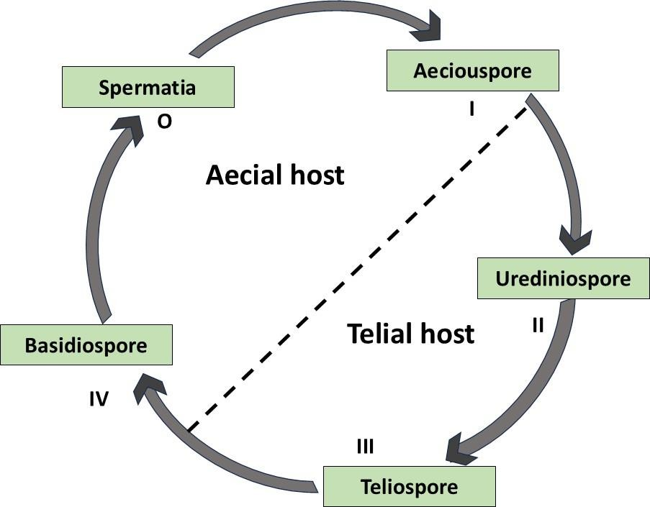

**Fig 2.1; Typical life cycle of some rust fungi, such as *Puccinia graminis***. Basidiospores (iv) cause infection only on a specific primary host (aecial host) during their haplophase. On the given initial host, monokaryotic spermatia (0) form and collectively fertilize aeciospores (i). Then, dikaryotic aeciospores are released randomly onto their secondary host (telial host). Urediospores, other vegetative propagules, are preferred so as to multiply in considerable amounts in order to spread effectively. Finally, teliospores (iii) are formed on the same host.

Autoecious rust fungi live their whole life cycle on a single host, in contrast to heteroecious species. Because they lack the aecial, uredinial, and spermogonial phases, certain rust fungus that are categorized as microcyclic have a shorter life cycle. Other types, including macrocyclic and demicyclic rusts, can be either autoecious or heteroecious and can either have all five spore stages or just the uredinial stage. *P. allii* is an example of a macrocyclic, autoecious rust that develops on a single host plant through all five phases (pycnia, aecia, uredinia, telia, and basidia (promycelia)) (Anikster *et al*., 2004).

In contrast to the more complex macrocyclic life cycles, simpler life cycles—typically with fewer than three spore stages—represent more sophisticated evolutionary adaptations, according to evolutionary study. Nonetheless, research on the interaction of rust fungi, their hosts, and the evolutionary forces causing these adaptations is still ongoing. To understand the coevolutionary interactions between these parasitic fungi and their plant hosts, it is essential to understand these intricate life cycles and their host specificity (Anikster *et al*., 2004).

## 2.2 Importance of Studying Rust Fungi

### 2.2.1 Economic and agricultural impact

Any fungi of the order Pucciniales are famous for causing the most devastating diseases of economically significant crops, thus severely disrupting agricultural ecosystems. Historically, these pathogens have caused epidemics and even local extinctions of host plants, caused food shortages and impacting natural plant populations (Carefoot and Sprott, 1967; Ordonez *et al*., 2009; Carnegie and Pegg, 2018). Among the many species of rust fungi, those from the genus Puccinia have gained particular attention because of their economic impact on cereal crops. These fungi exhibit a heteroecious life cycle, meaning they shift between two distinct plant hosts. For instance, *Puccinia coronata* is mainly aimed at oats (Ho *et al*., 2024), while *P. graminis* infects wheat, barley, and oats (Williams, 1984; Bolton *et al*., 2008). Other important species include *P. helianthi* (sunflower rust), *P. hordei* (barley rust), *P. purpurea* (sorghum rust), *P. melanocephala* (sugarcane rust), *P. recondita* (rye rust), *P. sorghi* (maize rust), *P. striiformis* (yellow or stripe rust affecting wheat and barley), *P. triticina* (wheat leaf rust), and *P. malvacearum* (hollyhock rust). Some of these fungi, including *P. graminis*, *P. triticina*, and *P. striiformis*, caused devastating seasonal outbreaks in North America, India, Mexico, and South America.

Quietly, the economic impact of the rust diseases is enormous, with yield losses attained in wheat and other cereal crops. Dollar estimates of annual losses caused by stripe rust (*Puccinia striiformis* f. sp. tritici) and stem rust (*Puccinia graminis* f. sp. tritici) stand at approximately $979 million and $1.12 billion, respectively (Beddow *et al*., 2015; Pardey *et al.*, 2013). In Australia, farmers spend between

$40 million and $90 million a year on fungicidal treatments to control these diseases; while wheat leaf rust is generally less virulent, early infections can lead to losses exceeding 50% in some regions and seasons (Huerta-Espino *et al.,* 2011).

### 2.2.2 Ecological significance

The rust fungi also show a common range in their hosts, infecting trees, shrubs, grasses, and crops. Moreover, with different species that specialize in different plant parts such as leaves, stems, roots, and fruits. Host specificity in rust fungi is one of the most studied features. Thus, there is little pathogenicity of *Puccinia graminis* from diseased wheat to oat and rye; while *P. graminis* strains from oat and rye are said to be weakly infective on wheat (Ordonez *et al*., 2009). This specificity affects plant community composition by selective effects on some species or genotypes, possibly altering the dynamics in the ecosystem (Lu *et al*., 2022; Ordonez *et al*., 2009).

Impacts of rust fungi on plants range from seedling mortality to growth suppression in all phases of their development. Severe infections often result in cankers, galls, and premature defoliation, as well as stunted growth, reduce photosynthetic capacity, breakage, and even complete death of plants (Avasthi *et al*., 2023; Lu *et al*., 2022). Such losses arise in both natural ecosystems and agriculture, and that is, in terms of sustainable yields.

Some species of the rust fungi demonstrate remarkable plasticity to environmental change in temperature, precipitation rates, and atmospheric changes. For example, wheat leaf rust is far more widely distributed than is stem and stripe rust because of this adaptability to the environment (Huerta-

Espino *et al*., 2011; Kolmer *et al*., 2009). In addition, climate change amplifies the spread and adaptation of rust fungi, imposing a new threat to ecosystems and cultivated plants.

Environmental factors play a key role in the dispersal and survival of rust fungi that are often insensitive to geographical distance. Conversely, it is the urediniospores formed during the uredinial stage which matter. They are dispersed to long distances by winds and deposited on the susceptible hosts mostly encouraged by rainfall (Lu *et al*., 2022). However, airborne urediniospores are responsible for transboundary dissemination of wheat rusts that pose global concern, ignoring national borders. (Lu *et al*., 2022; Yang *et al*., 2023).

## 2.3 Evolutionary Analysis of Rust Fungi

### 2.3.1 Phylogenetic Studies

#### **2.3.1.1** **Overview of phylogenetic methods**

Phylogeny reconstruction methods can be classified into distance-based and character-based approaches. The distance-matrix methods were first introduced by Fitch and Margoliash (1967) and Cavalli-Sforza and Edwards (1967). These methods utilize a distance matrix and cluster techniques to determine the evolutionary distance between each pair of sequences. Distance matrix approaches include neighbor-joining (Saitou and Nei, 1987), least squares (Cavalli-Sforza and Edwards, 1967), and minimal evolution (Rzhetsky and Nei, 1992). Among them, neighbor-joining and minimal evolution are the most commonly used. The minimum evolution method identifies the most reliable evolutionary tree as the one with the shortest length, which is determined by calculating the total length of all potential trees (i.e., the sum of the lengths of all branches).

According to Felsenstein (1983), the maximum parsimony approach quantifies the minimum number of evolutionary modifications required for one sequence to transition into another. This approach constructs a tree from directly aligned sequences, focusing only on the informative regions. Multiple

test trees with varying topologies are generated based on the similarities and differences of the sequences. Each tree is assigned a score indicating the fewest modifications needed for two sequences to become identical. Subsequently, each branch is given a score, and the tree with the lowest final score is selected.

One popular method for reconstructing evolutionary trees is the maximum likelihood approach. The main idea behind this method is to predict the relationships between objects of interest by estimating the probability of a hypothetical tree. The final tree is then chosen based on its likelihood of accurately predicting the variables being considered. The probability of the sequences at opposite ends of a branch converting after divergence is determined using differential equation approaches, which are based on evolutionary models that describe the relative probability of certain events (such as different types of mutation) (Salemi and Vandamme, 2003). This model describes all the observable and ancestral sequence evolution events that have occurred throughout the tree. Nucleotide and amino acid substitution and replacement models are essential in this probability-based method (Le and Gascuel, 2008; Salemi and Vandamme, 2003). An important part of this procedure is determining which tree is more prevalent over a large number of subsamples using the bootstrap method. Subsamples, which are the same size as the original tree, are created through repeated sampling with replacement. This process generates different branching patterns in the trees. While both the Bayesian inference method and the maximum likelihood method are similar, they differ in terms of the treatment of the model's parameters. In the Bayesian method, the parameters are treated as random variables with a statistical distribution, whereas in the maximum likelihood method, these parameters are fixed, unknown constants (Yang and Rannala, 2012). The posterior probabilities, which are used for all inferences, are computed here using Markov chain Monte Carlo methods (Hastings, 1970; Larget and Simon, 1999). By assigning a prior distribution to the parameters that reflect the accuracy of the trees, posterior

probabilities are generated. Any modification to the prior parameters can greatly impact the posterior probability. Moreover, these techniques allow for independent branch lengths in the unrooted trees.

**2.3.1.2.** **Key Insights into the Phylogeny of Rust Fungi**

Phylogenetic studies of rust fungi are important for identifying the evolutionary relationships among different species, providing insights into their divergence, speciation events, and evolutionary history. Furthermore, phylogenetic analyses have helped resolve taxonomic issues within the Pucciniales order, clarifying familial classifications and placing orphaned genera in a systematic context (Aime, 2006; Aime *et al*., 2017; Scholler *et al*., 2022).

The first molecular phylogeny of rust fungi was presented by Maier *et al*., (2003), using sequence data from 28S rDNA. Their phylogeny indicated that the genera Thekopsora and Pucciniastrum, as well as the family Pucciniastraceae, were polyphyletic. However, in a recent molecular phylogeny using 18S and 28S markers, Aime *et al*., (2018) confirmed the generic concept presented by Cummins and Hiratsuka, although they also proposed that additional *Pucciniastrum* and *Thekopsora* species need to be placed in other genera. Aime and McTaggart (2021) reported a phylogeny of rust families based on three less variable markers: COx3, 18S rDNA, and 28S rDNA.

Studies on rust fungi phylogeny have highlighted the genetic diversity present within the group, showing variations in gene content, genome size, and gene order among different species (Stone *et al*., 2010). For example, comparative analyses of *Austropuccinia psidii* with other rust fungi revealed that the mitochondrial genomes of rust fungi are highly syntenic, indicating a conserved organization of genetic elements across these species (Almeida *et al*., 2021).

Based on previous studies, phylogenomic approaches have identified expansions of gene families encoding secreted proteins, including virulence effector genes, which play a crucial role in the

interaction between rust fungi and their host plants (Duplessis *et al*., 2011). Understanding the phylogenetic relationships of rust fungi has shed light on the processes underlying host specificity, revealing how closely related rust fungi have evolved to infect distantly related host plants.

According to Liu and Hambleton (2010), a phylogenetic analysis of 30 species of stripe rust, *Puccinia striiformis*, based on molecular and morphological evidence confirmed that there is less diversity among these species, even though they have the widest host range within the population Triticeae, including *Aegilops, Elymus, Hordeum, and Triticum.*

By studying the phylogeny of rust fungi, researchers have gained valuable insights into their evolutionary patterns, genetic diversity, and adaptation strategies, contributing to a better understanding of these fascinating plant pathogens (Aime *et al*., 2017).

### 2.3.2 Evolutionary History

#### **2.3.2.1Evolutionary Relationships within Pucciniales**

The earliest theories suggested that the evolution of rust fungi underwent a coevolutionary process with their host plants, migrating from ferns to gymnosperms and eventually to angiosperms (Savile, 1971). However, later phylogenetic works countered the assumptions of earlier theories and improved understanding of evolutionary dynamics within Pucciniales (Hart, 1988; Sjamsuridzal *et al*., 1999). The different studies suggest that in terms of coevolution, the aecial stage of rust fungi is closer to its host than the telial stage, suggesting that the relationship between the two is largely significant in evolution (Aime *et a*l., 2018).

Good examples of host specialization in the group are within *Puccinia graminis* and wheat stem rust fungus, consisting of different formae speciales adapted to infect specific cereal crops like wheat, oat, and rye (Anikster, 1984). That specialization might have taken place thanks to the coevolution between

the pathogen and its host plants (Ordonez *et al*., 2009). While the early molecular studies suggested that diversification of rust fungi had taken place through coevolution or small host shifts, recent evidence illuminates the role of larger host jumps in their evolutionary history (Aime, 2006; McTaggart *et al*., 2016). For instance, Phragmidiaceae and Raveneliaceae rust fungi are specialized on Rosaceae and Fabaceae hosts, while the Endoraecium and Uromycladium species have become specialized in Acacia hosts in Australia (Aime, 2006; McTaggart *et al*., 2016).

Molecular phylogenetic studies inform that large host jumps played a significant role in the diversification of rust fungi; through host jumps, the rust fungi were able to infect a wide range of plant species spanning about 160 million years or so (McTaggart *et al.,* 2016). The molecular data suggest that the closest common ancestor of modern rust fungi arose on early gymnosperms, such as Taxales and Araucariaceae (McTaggart *et al*., 2016). Some further evidence indicates that rust fungi are relatively recent in evolutionary distance with their last common ancestor possibly dating back anywhere from 113 to 115 million years in the Cretaceous age. This timeline is much earlier than was presumed, thus showcasing their adaptability and evolutionary success (Aime, 2006). Silva *et al*., (2015) reported that lineage-specific-gene family expansion, gene loss, and reduced diversity of carbohydrate-active enzymes were the major events shaping the evolutionary history of rust fungi.

#### **2.3.2.2 Genetic Markers in Evolutionary Studies**

The genetic markers have opened the way towards the understanding of the evolutionary history, phylogeny, and diversity of rust fungi. A major advancement in the field was the design of rust-specific primers targeted for three ribosomal DNA (rDNA) regions: internal transcribed spacer (ITS), large subunit (LSU/28S), and small subunit (SSU/18S). Previous phylogenetic studies used mainly LSU and SSU markers to study evolution on the infrageneric and infrafamilial levels (Aime, 2006; Beenken, 2017; Maier *et al*., 2003; Scholler and Aime, 2006; Yun *et al*., 2011).

At the species level, other genetic markers, for example, the second-largest subunit of RNA polymerase II (RPB2), β-tubulin (B-tub), and translation elongation factor 1 alpha (TEF), are efficiently used to resolve relationships in Pucciniaceae, the largest family of rust fungi (Liu and Hambleton, 2010, 2013). Mitochondrial DNA markers, especially cytochrome c oxidase subunit 3 (CO3), have been identified as effective barcodes for rust fungi and are widely used in phylogenetic analyses (Vialle *et al.*, 2009; Beenken *et al*.,2015; Doungsa-ard *et al*., 2015; Feau *et al*., 2011; McTaggart *et al*., 2016).

ITS-based - ITS commonly used in conjunction with LSU and intergenic spacer regions- is the marker for the identification of close relatives within the rust fungi. However, several studies also consequently call into question its efficacy for molecular barcoding. A highly variable ITS has been reported in Pucciniales for intraspecific and intra-isolate levels, which renders them ill-suited for direct Sanger sequencing (Alaei *et al*., 2009; Virtudazo *et al*., 2001).

### 2.3.3 Evolution of Host Specificity

#### **2.3.3.1** **Mechanisms of host adaptation**

*Forma specialis* (f. sp.) (Anikster, 1984) in rust fungi refers to the variations in the rust fungi according to the host specification inside a species. For instance, wheat leaf rust was originally designated within Puccinia recondita; however, later usability in the alternate hosts of the family Boraginaceae in members of the same genus proved it to be sexually incompatible with them. Hence, it was accorded a status of separate species, *Puccinia triticina* Eriks. (Ordonez *et al*., 2009; Xia *et al*., 2018). Such taxonomical refinements highlight the complex ways in which pathogens interact within host- pathogen relationships.

A foremost strategy employed by rust fungi and other plant pathogens involves effector proteins that interfere with host cellular processes, minimize immune responses, and enhance the odds of infection

(Thines, 2019). Genomic studies on the obligatory biotrophic nature of rust fungi demonstrated that a considerable number of expanded gene families appear to be lineage-specific, suggesting that such pathogens can produce massive amounts of effector-like small secreted proteins (Duplessis *et al.,* 2011). Additional characterizations of the rust fungal genomes have signified that a substantial number of transcripts are regulated by differential expression during infection, including those coding peptidases and lipases, secreted transporters, and carbohydrate-cleaving enzymes, which are crucial elements for host infiltration and nutritional absorption (Duplessis *et al*., 2011).

In addition to changes such as mutations and recombination that constantly accommodate the pathogens to new host niches, genetic changes can also modify virulence factors or receptors for host recognition (Xia *et al*., 2018). In *Puccinia striiformis f. sp. tritici,* the pathogen of wheat and barley stripe rust, genomic analyses indicate that gene loss is an important mechanism for host adaptation at the specialist level (Xia *et al*., 2018). This gene loss may account for homologous sequences that might have subsequently been lost in one isolate in comparison to another due to incorporation by transposable elements or via segmental deletions in the genomic sequence. This expression in *P. striiformis* reflects the pattern of genome evolution also seen in other filamentous plant pathogens (Xia *et al*., 2018).

These broad genomic variations among dikaryotic uredinia spores of *P. striiformis* have caused many gene losses and occasional gene gains; hence, the divergence of formae speciales was influenced (Xia *et al*., 2018). Pathogens may gradually expand their host range by acquiring genetic variants that improve their ability to infect novel hosts. Variations in telomeric repeats among isolates suggest that such alterations in telomeric regions might be correlated with host adaptation (Xia *et al*., 2018). Some pathogens also modify themselves physiologically over time to escape extreme ecological conditions and defenses that host species may present so they can evade host immune responses (Thines, 2019).

Over time, rust fungi may co-evolve with their hosts, evolving adaptations that allow them to overcome plant defenses and establish a successful infection (Thines, 2019). Interactions with other pathogens may also help them invade new hosts by altering the immune response or possibly nutrient availability in the host (Thines, 2019). In particular, rust fungi are known to secrete large amounts of effector-like proteins that likely manipulate host immune systems, thus promoting parasitic colonization (Duplessis, 2011). Collectively, these mechanisms are fundamentally important in pathogen adaptation to new host species and ecological niches.

#### **2.3.3.2** **Examples of host shifts and co-evolution**

Host shift refers to the transition of a pathogen from one host to the other by different species, with these host species often being phylogenetically distant. This move allows the pathogen's continued existence and diversification through evolutionary time. It is an essential process of pathogen speciation and the formation of novel host-pathogen interactions. Various combinations of effector protein activity, genetic mutations, physiological changes, co-evolution with the host, interaction with other pathogens, and microbiome interactions contribute to successful host jumps (Sharma *et al*., 2014; Vagi *et al*., 2007; Telle *et al*., 2011; Cooper *et al*., 2002).

During different stages of their life cycles, rust fungi might undergo host jumps during which they change from one or multiple host species to others or even between host kingdoms. Such shifts lead to different evolutionary lineages within fungal groups, promoting genetic dissemination and adaptation to new host environments (Van der Merwe *et al*., 2008; Aime *et al*., 2018). Studies by McTaggart *et al*., (2016) conclude that the diversification of rust fungi is largely a consequence of host jumps rather than maintained co-evolution. Over the past 160 million years, the rust fungi fully expanded their host range, becoming extremely virulent across various plant species (McTaggart *et al*., 2015).

Host shifts have been demonstrated in a number of rust genera such as Phakopsora (Maier *et al*., 2016), Puccinia (Van der Merwe *et al*., 2008; McTaggart *et al*., 2016), and Uromycladium (Doungsa-ard *et al*., 2015), as well as in family groups such as Mikronegeriaceae and Sphaerophragmiaceae. These examples illustrate that rust fungi can successfully jump to new host plants and hence increase their infection potential beyond the classical long-term co-evolution relationships.

Nevertheless, co-evolution remains a major constraint on some rust fungi. For instance, species of the genus Endoraecium formed a close evolutionary relationship with their host, Acacia, suggesting a long-term, specialized interaction. There are several examples of co-evolution actually taking place in the rust fungi of the Phragmidiaceae family, along with a few stable associations with members of the Rosaceae family (McTaggart *et al*., 2016). They show the higher amplitude of host-pathogen interactions where host jumps and co-evolution both play parts in the rust host's evolutionary characters.

## 2.4 Rust Fungi on Coffee

Coffee is a crucial crop for many countries and a significant source of income for millions of people, which has a profound impact on the global economy. More than 80 countries cultivate coffee, and some heavily rely on it as their primary source of income (Lu *et al*., 2022; McCook and Vandermeer, 2015). For instance, in the year 2020–2021, worldwide coffee production reached a record-breaking

176.1 million kg, marking a 5.5 million kg increase from the previous year. Brazil, the largest coffee exporter in the world, contributes one-third of all coffee exports. In the year 2020–2021, Brazil produced a record- breaking 67.9 million kg of coffee, which indicates a 15% increase compared to 2019. China holds the title for the country with the highest coffee consumption, while Finland boasts the largest per capita consumption. Consequently, coffee production stands as the second most traded commodity globally, following oil. The two main species of coffee cultivated worldwide are

*Coffea arabica and Coffea canephora* (robusta), with arabica accounting for 60% and robusta for 40% of global production (Lu *et al*., 2022).

However, coffee growers in the tropics face several challenges when it comes to agricultural productivity (Harvey, 2014). The impact of climate change has significantly altered the way coffee is grown, as this temperature-sensitive plant is greatly affected. Consequently, these changes have led to an increase in fungal infections, invasive pests, and changes in crop yields and quality. One of the primary concerns affecting coffee production and quality is fungus infection (Lamessa *et al*., 2015; Lu *et al*., 2022; Demelash *et al*., 2018).

The production of coffee is greatly impacted by rust infections, such as coffee leaf rust caused by *Hemileia vastatrix*. These diseases can lead to reduced crop production and significant financial losses. Coffee leaf rust is a major threat to the global coffee output as it affects more than 50 coffee-growing countries and causes severe damage to vulnerable plantations. The losses in coffee productivity due to coffee leaf rust can be divided into two categories: primary losses, resulting from fruit loss due to defoliation and the death of injured branches, and secondary losses, which occur as plants expend energy to recover from the initial losses (Cerda *et al*., 2017). The impact of coffee leaf rust on productivity can range from 15% to 20% and even reach up to 70% (Adepoju *et al*., 2017; Ramírez- Rodríguez *et al*., 2020). For instance, between 2008 and 2011, Colombia reported losses of nearly 31% compared to its 2007 production (Villarreyna *et al*., 2020). In Mexico, the coffee leaf rust outbreak since 2012 has cost the country an estimated 50% of its total production (Castillo *et al*., 2020; Henderson, 2020). Likewise, Guatemala experienced losses ranging from 59% to 70% in 2012 (Dupre *et al*., 2022). The decline in coffee prices further exacerbated the losses, resulting in farmers receiving significantly lower payments for their reduced crop yields between March 2011 and December 2013. Payments to coffee growers decreased by half during this period (International Coffee

Organization, 2015). As a consequence, the total amount of coffee exported from Central America plummeted by 50% within a few years.

Furthermore, coffee growers have experienced a pricing or cost squeeze. Just as their revenue from coffee was decreasing, the cost of vital supplies such as fertilizers and fungicides was increasing. This has also had an impact on day workers employed in coffee plantations, with a reduction of up to 33% in the need for their services. The pay of those laborers who were able to secure work has decreased by as much as 20% (McCook, and Vandermeer, 2015).

The causal agent of Coffee Leaf Rust (CLR), Hemileia vastatrix, is contained within the Phylum Basidiomycota, Class Pucciniomycetes, Order Pucciniales, Family Pucciniaceae, and Genus *Hemileia* (Salazar-Navarro et al., 2024). An obligate biotroph, it relies entirely on its live host plant for nutrition and completion of its life cycle. *H. vastatrix* infects Coffea spp. and causes damage to domestic and wild varieties. Although the fungus mainly targets *C. arabica*, some varieties of *C. canephora* are also prone to infection (Gullino, 2021; Salazar-Navarro *et al*., 2024).

Though another rust fungus, *H. coffeicola*, can also infect *C. arabica,* only *H. vastatrix* has had a serious economic impact on coffee production internationally, having first been reported in the most virulent epiphytotic in Sri Lanka in 1869 (Talhinhas *et al.*, 2014; Talhinhas *et al*., 2017).

Important morphological features include different types of spores, and specialized reproductive structures. Uredinospores are one-celled, oval to reniform, with thick, mostly hyaline walls about 1

`m thick. They have a hydrophobic surface, with protuberances or spines on the dorsal and convex sides, while the ventral and concave sides are smooth (Salazar-Navarro *et al*., 2024). Urediniospores may show up to 300 spines in matured specimens, which aid in their adhesion to leaf surfaces (Voegele *et al*., 2009). Unlike urediniospores, the teliospores of *H. vastatrix* have a smooth surface. Sori are

formed on the upper leaf surface and occur more or less in a bouquet manner on infected leaves (Talhinhas *et al*., 2014).

*H. vastatrix* has a hemicyclic life cycle with autoecious reproduction. Its reproductive cycle involves the production of uredinospores, teliospores, and basidiospores, with uredinospores being the primary source of inoculum for spreading the pathogen. Uredinospores are the main source of inoculum for spreading *H. vastatrix*. Coffee leaves are resistant to basidiospores, while teliospores sporadically reinfect their host (Voegele *et al*., 2009; Talhinhas *et al*., 2014).

Another key feature of *H. vastatrix's* uredinospores is their resistance to unfavorable conditions, allowing them to survive extended periods of drought, nutrient scarcity, and low temperatures. Uredinospores can remain dormant until environmental conditions become favorable. For uredinospore germination, a duration of 6-8 hours in dark, moist conditions with free water is necessary. Uredinospores germinate at temperatures ranging from 21°C to 27°C with high relative humidity (up to 80%). The primary infection structure for the asexual cycle of *H. vastatrix* is represented by urediniospores, which repeatedly infect the sorus (Talhinhas *et al*., 2017; Gichuru *et al*., 2021; Lorrain *et al*., 2018; Talhinhas *et al*., 2014).

## 2.5 Coffee Rust Fungi in Sri Lanka

Sri Lanka (then Ceylon) was introduced to coffee in the early nineteenth century, where it became a principal export crop (Talhinhas *et al*., 2016; Koutouleas *et al*., 2024). Coffee quickly became the leading crop, covering almost 400,000 acres (160,000 ha) by 1870. However, in 1875, the coffee leaf rust fungus *Hemileia vastatrix* arrived on mountain weather fronts from southern India and within two decades, it had completely devastated Sri Lanka's coffee industry.

By the 1900s, coffee production had plummeted from over 650 million pounds (450,000 tons) to just a few million pounds (with an output rate of less than two tons per hectare). Many coffee farms were forced out of business, and this once vibrant sector came to a standstill. This plant disease epidemic is considered one of the largest and most catastrophic in history (Talhinhas *et al*., 2016; Koutouleas *et al*., 2024).

Today, coffee cultivation in Sri Lanka is a small-scale enterprise, with approximately 8,000 hectares used for production. The country produces around 20,000 metric tons of coffee each year, but the majority is Robusta (*Coffea canephora*) rather than the high-grade Arabica (*Coffea arabica)*. Despite its historical significance and the significant role, it once played in the domestic economy, coffee now holds little economic importance for Sri Lanka. Sri Lanka is the only country that has shown resistance to *H. vastatrix,* but it still poses a major threat to coffee production in the country, with estimated yield losses of 30-35% on average.

The coffee rust disease has had a devastating economic impact on Sri Lanka, and its current threat cannot be underestimated. The collapse of the coffee industry in the late 19th century due to this disease had severe social and economic repercussions, including starvation and unrest. Additionally, the continued presence of coffee rust makes it difficult for farmers in Sri Lanka to establish sustainable and profitable businesses, as the industry has struggled to rebound over time.

Over the past century and a half, Sri Lankan researchers have conducted extensive studies on *H. vastatrix* and coffee rust disease, making it a well-known topic among those involved in crop protection for agricultural crops in the country (Talhinhas *et al*., 2016; Koutouleas *et al*., 2024). This research has focused on pathogenesis, epidemiology, and disease control methods of the pathogen, as well as resistance studies in coffee genotypes (Talhinhas *et al*., 2016; Koutouleas *et al*., 2024). Sri Lankan researchers have identified more than 50 physiological races of *H. vastatrix,* studied resistance

in coffee germplasm, and explored potential control measures such as chemical, cultural (Caicedo, 2014), and biological approaches. This research remains crucial in guiding ongoing efforts to limit the damage caused by coffee rust in Sri Lanka and other affected regions.

# 3.0 METHODOLOGY

## 3.1 Sample collection

Coffee rust leaf samples were collected from the Matale and Balangoda districts in Sri Lanka. Based on references, rust-infected coffee leaves were identified by characteristic symptoms, notably the presence of yellowish-orange spore aggregations on the underside of the leaves. The samples were placed in Ziplock bags and transported to the Department of Plant and Molecular Biology at the University of Kelaniya for further experimentation. Detailed records of host plants, agronomic characteristics, and ecological data associated with each sample were documented during the collection process.

## 3.2 Isolation of fungal spores from diseased leaf sample

The rust-infected leaf samples were examined under a stereo microscope (OLYMPUS SZ61, Japan) to identify microparasites' presence or absence on the fungal spores. Eppendorf tubes and needles were sterilized before use. Rust spores free from microparasites were then collected using the sterilized needle and placed into Eppendorf tubes containing absolute ethanol for further analysis.

## 3.3 Morphological characterization

For morphological analysis, microscopic slides were prepared by mixing rust spores with water on the slide. These slides were then carefully examined under a light microscope (ECLIPSE E100LED MVR, China) at 40× magnification. Key morphological characteristics of the rust spores, including the epidermal position of pustules, spore size (length and width), spore shapes, color, and wall

thickening, were observed for each sample. All data were meticulously recorded for further analysis.

## 3.4 DNA extraction, PCR, Sequencing

**Pre-treatment of spores**

Prior to DNA extraction, the spores were pre-treated to remove contaminants. A solution of 10% Chlorox, prepared with 100 ml of Chlorox and a drop of Tween 20, was added to the spore tube in a volume of 1 ml. The mixture was incubated at 60°C for 3 minutes. It was then vortexed briefly and centrifuged at 14,000 rpm for 2 minutes. The supernatant was removed, and the process was repeated to ensure effective cleaning. The resulting spore pellet was dried and stored at -20°C until DNA extraction. At each step, the spore suspension was observed under a light microscope to confirm the removal of unwanted materials.

**DNA Extraction**

For DNA extraction, spore cells were transferred into sterile 1.5 ml microcentrifuge tubes, with up to 10810^8108 cells used for each sample. The samples were centrifuged at 6,000 x g for 5 minutes, and the supernatant was carefully removed. The pellet was resuspended in 600 µl of sorbitol buffer, and 200 U of either lyticase or zymolase was added to digest the fungal cell walls. The mixture was incubated at 30°C for 30 minutes. Following this, the sample was centrifuged at 2,000 x g for 10 minutes to harvest the spheroplast. The supernatant was discarded, and the spheroplast was resuspended in 50 µl of Buffer CR.

The resuspended cells were lysed by adding 300 µl of Buffer CC, and the mixture was vortexed thoroughly. The lysate was incubated at 60°C for 10 minutes or until it became clear. During incubation, the tube was inverted every 3 minutes to ensure uniform mixing. To remove proteins, 400 µl of Buffer CB was added to the lysate, and the mixture was shaken vigorously. The sample

was then centrifuged at 12,000 x g for 1 minute, and the clear supernatant was transferred to a DNA-binding column.

The DNA-binding column was prepared by placing it in a 2 ml collection tube. The supernatant was transferred to the column and centrifuged at 14,000 x g for 30 seconds. The flow-through was discarded, and the column was washed with 400 µl of Buffer W1, followed by centrifugation at 14,000 x g for 30 seconds. Subsequently, 600 µl of Buffer W2 (containing ethanol) was added to the column and centrifuged at 14,000 x g for 30 seconds. The column was further centrifuged at 14,000 x g for 2 minutes to remove residual Buffer W2.

For DNA elution, the DNA-binding column was transferred to a new 1.5 ml microcentrifuge tube. Pre-heated Buffer BE or TE (50–200 µl) was added to the center of the column matrix, and the sample was left to stand at 60°C for 3 minutes. The column was centrifuged at 14,000 x g for 2 minutes to elute the purified DNA.

Following DNA extraction, PCR was performed using specific primers for the LSU, and SSU regions. The PCR products were subsequently sequenced for further analysis.

## 3.5 Data collection and phylogenetic analysis

A dataset for the order *Pucciniales* was created to calibrate our own data. Accession numbers and associated information for this dataset (provided in the supplementary table) were obtained from previous studies. Sequences for LSU, SSU, and Cox3 regions were retrieved from the NCBI GenBank database as FASTA files using their respective accession numbers.

The dataset includes 225 taxa from across the order, incorporating two nested subgroups. It consists of taxa, with 224 ingroup taxa representing all known major lineages of rust fungi, as determined by multiple studies (McTaggart *et al*., 2016; Aime *et al*., 2018; Aime and McTaggart, 2021; Zhao *et al*., 2023). One outgroup taxa represent the sister order to Pucciniales, following

For the alignment, the sequences were trimmed to begin with the first codon of the reading frame. All the reference sequence data and our sequenced data of the above 3 regions were compiled separately, and sequences were aligned using a multiple sequence alignment program (Bioedit, crustal W). Aligned sequences for four gene regions were combined using MEGA software version

10.1.8 and Bioedit Sequence Alignment Editor version 7.2.5. Phylogenetic analysis was performed using single and combined genes of LSU, SSU and COX3. The phylogenic relationships were analyzed using Maximum likelihood (ML) analysis. A well-supported phylogenetic tree will be constructed for Pucciniales using molecular data. The phylogenetic tree was reconstructed using 26 Maximum likelihood (ML) analyses available in RaxML-HPC Blackbox 8.2.1.2 software in CIPRES Science Gateway.

Datasets were assembled using MUSCLE (Edgar 2004), with additional manual editing performed in Mesquite v. 2.75 (Wp, M. 2011). The data were analyzed using RAxML-HPC2 on the XSEDE platform (Stamatakis *et al*., 2008) with default settings, including 1000 bootstrap replicates, accessible through the CIPRES Science Gateway (Miller *et al*., 2010). Additionally, MrBayes (Ronquist *et al.*, 2012) will be used to reconstruct the evolutionary relationships between the isolated fungal strains and known species.

## 3.6 Divergence time analysis and Ancestral state reconstruction

Divergence time estimations were conducted using a secondary calibration procedure (Renner 2005), which is commonly employed in fungal studies due to the limited availability of fossil records for establishing internal calibration points (Matheny *et al*., 2009; Floudas *et al*., 2012; Wilson *et al*., 2012). Molecular clock models were applied by incorporating fossil records or

Molecular dating analyses were performed using the BEAST v1.10.4 program (Drummond *et al*., 2006; Drummond and Rambaut 2007), utilizing multi-gene loci data (LSU, SSU, COX3) and considering a secondary calibration nodes (Stem of Pucciniales, Mean 176 MYA, SD 20 MYA, Yule.birth Rate model, 40,000,000 generations, 1,000 sample frequency). Bayesian Binary MCMC analysis was carried out in RASP 3.2.1 (Reconstruct Ancestral State in Phylogenies) to infer host ancestral character states using the time-calibrated maximum clade credibility tree reconstructed in BEAST. The results were interpreted with a focus on the divergence times of key lineages within Pucciniales.

# 4.0 RESULTS

## 4.1 Sample Collection

### 4.1.1 Study sites

Samples of coffee leaves infected with *Hemileia vastatrix* were collected from two distinct regions in Sri Lanka: Matale in the Central Province and Balangoda in the Sabaragamuwa Province. Both areas are recognized for their favorable climatic conditions for coffee cultivation. The Matale samples were collected from the Export Agriculture Research Center in Thibbatumulla, characterized by an average temperature range of 22–28°C, an elevation of 500–600 meters above sea level, and relative humidity levels between 65–80%. Samples from Balangoda were obtained from Damana, a region with an elevation of 700–900 meters, average temperatures of 20–25°C, and relative humidity ranging from 70–85% (**Table 4.1**).

### 4.1.2 Symptoms of Infection

The infected trees were identified as *Coffea robusta*, displaying symptoms of coffee rust disease. On the abaxial surfaces of the leaves, initial signs were observed as small, yellowish spots. These spots gradually expanded into larger lesions that transitioned into a bright orange coloration as the disease progressed (**Figure 4.1**). In heavily infected areas, the lesions coalesced, resulting in significant leaf damage.

Prominent uredinial pustules, the diagnostic feature of *H. vastatrix* infection, were observed as orange-yellow to pale-yellow aggregations on the lower surfaces of leaves (**Figure 4.1**). Sporulating pustules released abundant urediniospores, which are considered the primary inoculum for the pathogen’s secondary spread during the growing season. The dispersal of these

spores likely facilitated the rapid propagation of the disease across coffee plantations in the studied regions. This detailed observation of infected samples is presented in **Table 4.1**.

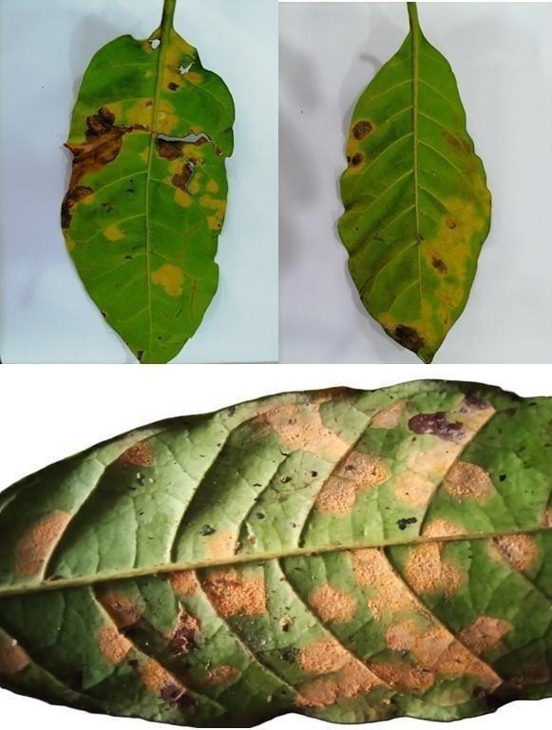

**Figure 4.1**: Coffee rust infected leaves with characteristic symptoms (Prominent uredinial pustules, were observed as orange-yellow to pale-yellow aggregations on the lower surfaces of leaves with significant leaf damage).

## 4.2 Spore Morphology of *Hemileia vastatrix*

The urediniospores of *Hemileia vastatrix* collected from Matale and Balangoda exhibited key morphological characteristics consistent with previous studies and some regional variations. Under light microscopy, the urediniospores were broadly ellipsoidal to elliptical in shape and exhibited a distinct half-smooth, half-rough surface morphology. Their walls were prominently thickened and

ornamented with echinulae. The echinulae varied in size and spacing, appearing finely distributed or more pronounced depending on the collection site. The spores contained carotenoid lipid granules, which imparted their characteristic yellow-orange pigmentation (**Figure 4.2**).

The morphological characters examined included urediniospore size, shape, echinulation, germ pore number and size, and shape of paraphyses. Germ pores and paraphyses were not observed in either sample, which is consistent with prior studies on *H. vastatrix*.

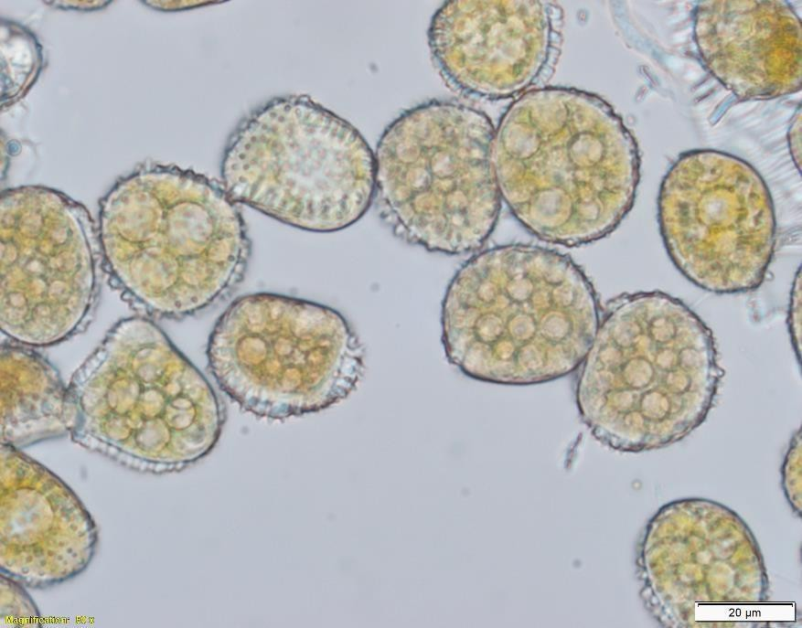

**Figure 4.2:** Carotenoid lipid granules observed in urediniospores

**Table 4.1: Comparative Analysis of Environmental Conditions, Symptomatology, Urediniospore and Morphological Characteristics of *Hemileia vastatrix* Collected from Matale (Central Province) and Balangoda (Sabaragamuwa Province) in Sri Lanka**

|  |  |  |
| --- | --- | --- |
| **Parameter** | **Matale (Central Province)** | **Balangoda (Sabaragamuwa**  **Province)** |
| **Sample Source** | Export Agriculture Research  Center, Thibbatumulla | Damana |
| **Elevation (m)** | 500–600 | 700–900 |
| **Average temperature (°C)** | 22–28 | 20–25 |
| **Relative Humidity (%)** | 65–80 | 70–85 |
| **Coffee Species** | *Coffea robusta* | *Coffea robusta* |
| **Symptoms Observed** | - Small, yellowish spots on  abaxial surface | - Small, yellowish spots on  abaxial surface |
| - Expansion into bright orange  lesions | - Expansion into bright orange  lesions |
| - Coalescence of lesions in  severe areas | - Coalescence of lesions in  severe areas |
| **Uredinial Pustules** | Orange-yellow to pale-yellow  aggregations on lower leaf surfaces | Orange-yellow to pale-yellow  aggregations on lower leaf surfaces |
| **Urediniospores** | 29.0 ,20.0 µm | 24.7 ,21.2 µm |
| **Urediniospore Shape** | elipsoidal | eliptical |

|  |  |  |
| --- | --- | --- |
| **Surface Morphology** | half-smooth(half-rough),  finely echinulate | hyaline to subhyaline, surface  distantly echinulate |
| **Wall Features** | 0.5- 1.2µm thick | 1- 2µm thick |
| **Echinulae** | echinulae 0.2- 0.5 mm wide at base, 0.5-1.0 mm high, distance between echinulae at apices 1.2 -1.5 mm (mean  1.3mm) wide. | echinulae 0.5- 0.8 µm wide at  the base, (0.8 -)0.9-1.4(-1.5)  µm high, distances between  echinulae at apices 2.0-2.1 µm (mean 2.1 µm) |
| **Pigmentation** | carotenoid lipid granules are  present in the cell wall | carotenoid lipid granules are  present in the cell wall |
| **Germ Pores** | Not observed | Not observed |
| **Paraphyses** | Not observed | Not observed |

## TAXONOMY

### 4.2.1 *Hemileia vastatrix* from Balangoda Site

***Hemileia vastatrix* Berk. & Broome, *Gard. Chron.*, London: 1157 (1869) Fig. 4.3**

**Host:** *Coffea robusta*

**Habitat:** The lower surface of Infected leaves of the coffee tree, Balangoda District, Sabaragamuwa Province, Sri Lanka.

**Note: -** Infected coffee leaves initially show small, yellowish spots that later expand and turn orange as the disease develops. These spots can combine, leading to more extensive lesions. The yellow-orange pustules (uredinia) are often visible on the lower leaf surface, releasing spores that can spread the infection.

**Asexual state**: - Uredinia, pale yellow to light yellow, pulvinate to elongate, approximately 0.2 -

0.5 mm long, 0.1- 0.2 mm wide. The generic name *Hemileia*, reflects the characteristic half-smooth (half-rough) morphology of the supposed asexual spores or urediniospores, which function as the dominant dispersal and infective propagules. Urediniospores are responsible for the secondary spread of the disease during the growing season. They are typically elliptical and measure about (18-)20-29(-32) (16-)18-24(-27) (mean 24.7 21.2 µm). Urediniospores showing the 1- 2µm thickened, heavily ornamented upper wall containing carotenoid lipid granules imparting the yellowish orange colour. Urediniospores are hyaline to subhyaline, surface distantly echinulate, echinulae 0.5- 0.8 µm wide at the base, (0.8 -)0.9-1.4(-1.5) µm high, distances between echinulae at apices 2.0-2.1 µm (mean 2.1 µm). Germs pore, and paraphyses were not observed.

### Materials examined:

Sri Lanka, Sabaragamuwa Province, Damana, Balangoda. with yellowish orange color uredinia on the abaxial surface of leaf with brownish black color necrosis on the leaf, collected on 24th July 2024, Specimen no. SLCR 02.

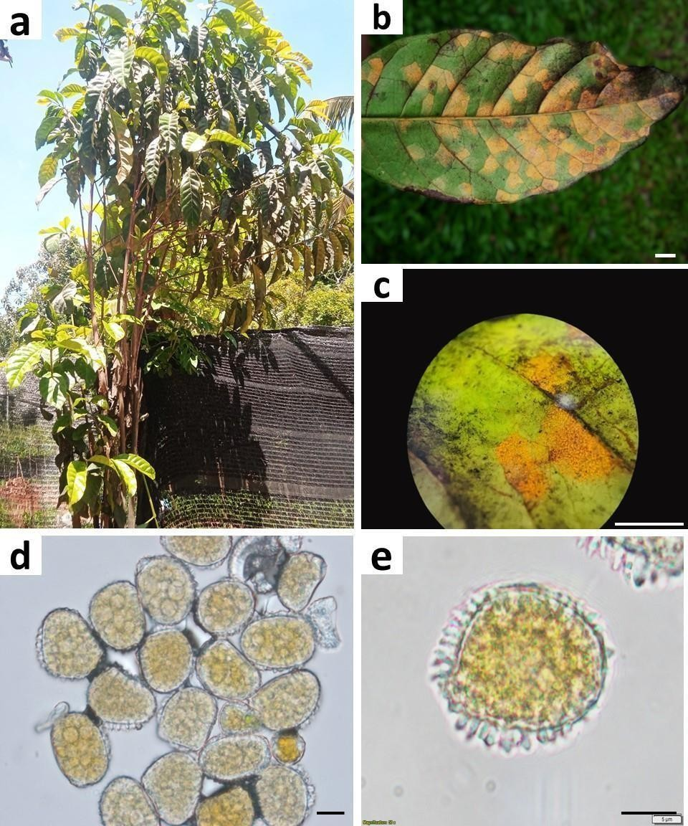

**Figure 4.3**: Symptoms and morphology of coffee leaf rust, *Hemileia vastatrix* collected from Balangoda District, Sabaragamuwa Province, Sri Lanka. (a) Rust fungi infected coffee tree, (b) Leaf symptoms on abaxial surface; (c) Detail of suprastomatal uredinial pustules aggregated over lower leaf surface; (d) Collection of spores; (e) A urediniospore. Scale bars, b-0.5 cm; c-1cm; d- 20µm; e-5µm.

### 4.2.2 *Hemileia vastatrix* from Matale Site

***Hemileia vastatrix* Berk. & Broome, *Gard. Chron.*, London: 1157 (1869) Fig. 4.4**

**Host**: *Coffea robusta*

**Habitat**: The lower surface of Infected leaves of the coffee tree, Matale District, Central Province, Sri Lanka.

**Asexual state**: - Uredinia mostly on adaxial leaf surface, light yellow to orange yellow. Urediniouspore shows the characteristic half-smooth (half-rough) morphology. Urediniospores broadly ellipsoidal (24-)27-29(-36), (22-)28-30 mm (mean 29.0 20.0 µm); finely echinulate, echinulae 0.2- 0.5 mm wide at base, 0.5-1.0 mm high, distance between echinulae at apices 1.2 -

1.5 mm (mean 1.3mm) wide. Urediniospores showing the 0.5- 1.2µm thickened, heavily- ornamented upper wall containing carotenoid lipid granules imparting the yellow-orange colour. Germs pores and paraphyses were not observed.

### Materials examined:

Sri Lanka, Central Province, Export agriculture research center, Thibbatumulla, Matale, with yellowish orange color uredinia on the abaxial surface of leaf with brownish black color necrosis on the leaf, collected on 25th July 2024, Specimen no. SLCR 01.

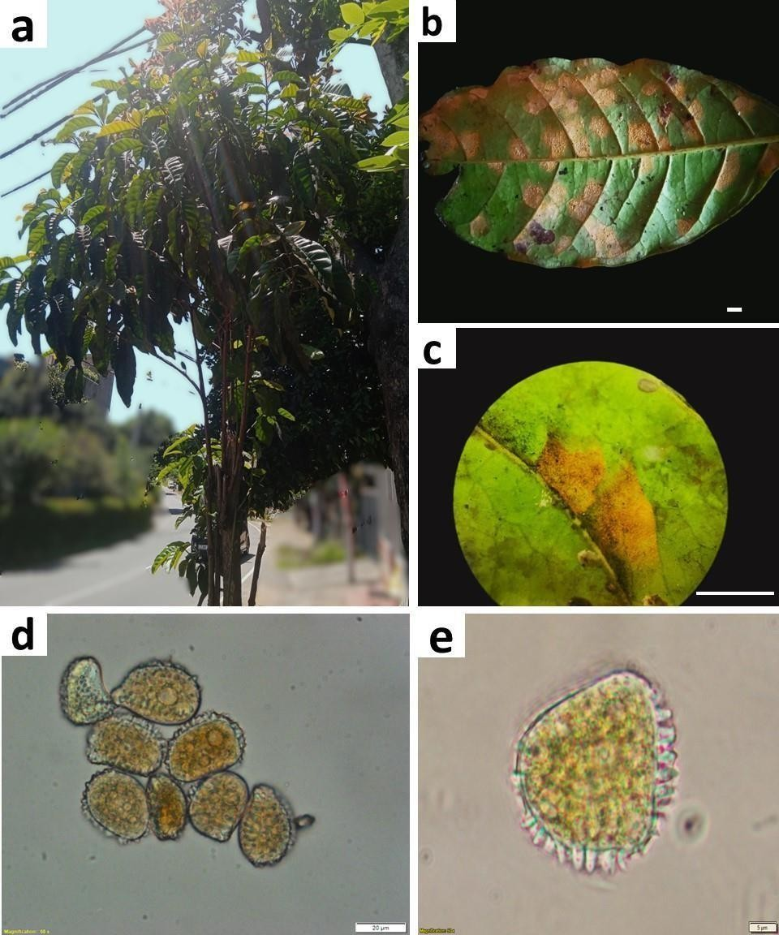

**Fig 4.4**: Symptoms and morphology of coffee leaf rust, *Hemileia vastatrix* collected from Matale District, Central Province, Sri Lanka. (a) Rust fungi infected coffee tree, (b) Leaf symptoms on abaxial surface; (c) Detail of suprastomatal uredinial pustules aggregated over lower leaf surface; (d) Collection of spores; (e) A urediniospore. Bars, b-0.5cm; c-1cm; d-20µm, e-5µm.

## 4.3 Phylogenetic analysis

This analysis focuses on the phylogenetic tree, which was constructed using 227 taxa of the order Pucciniales, including an outgroup, *Eocronartium muscicola.* The tree, constructed by the Maximum Likelihood method, is based on three gene regions: LSU, SSU, and COX3, providing a robust framework for understanding evolutionary relationships within this order. It gives more attention to coffee rust samples, namely *Hemileia vastatrix* SL1L and SL2L, by assessing their phylogenetic placement with bootstrap support. Indeed, this phylogenetic tree presents a number of distinct clades that correspond to known taxonomic families and genera within Pucciniales. The tree was rooted using *Eocronartium muscicola* as an outgroup, and some evolutionary divergences could be clearly seen.

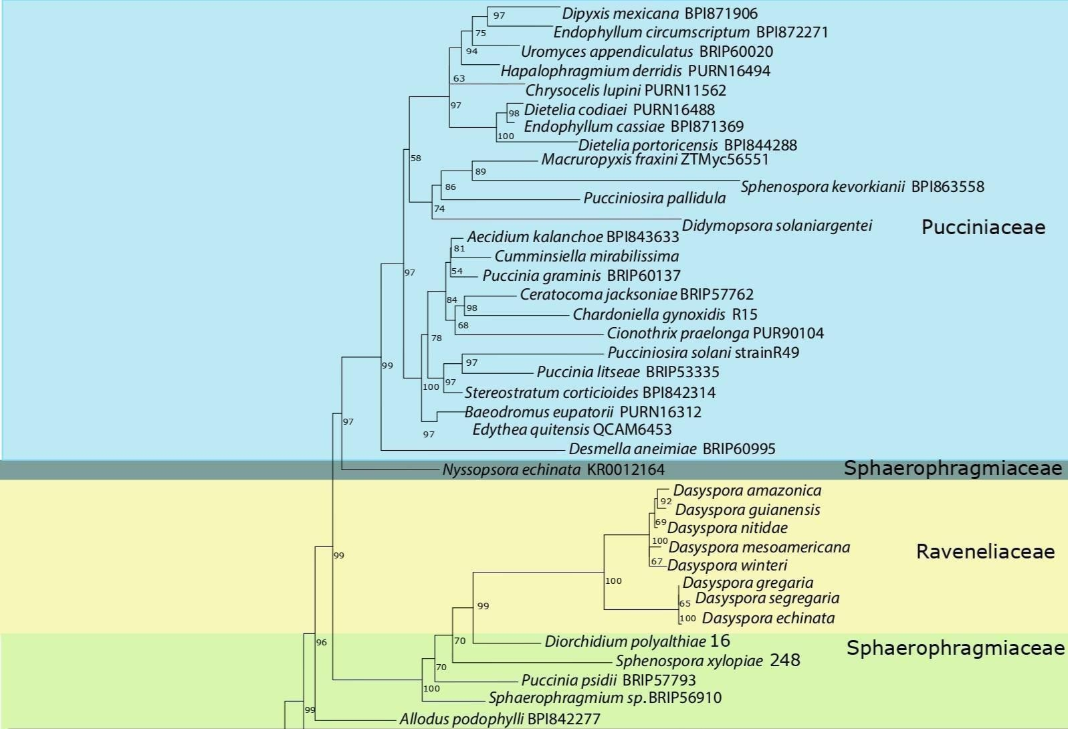

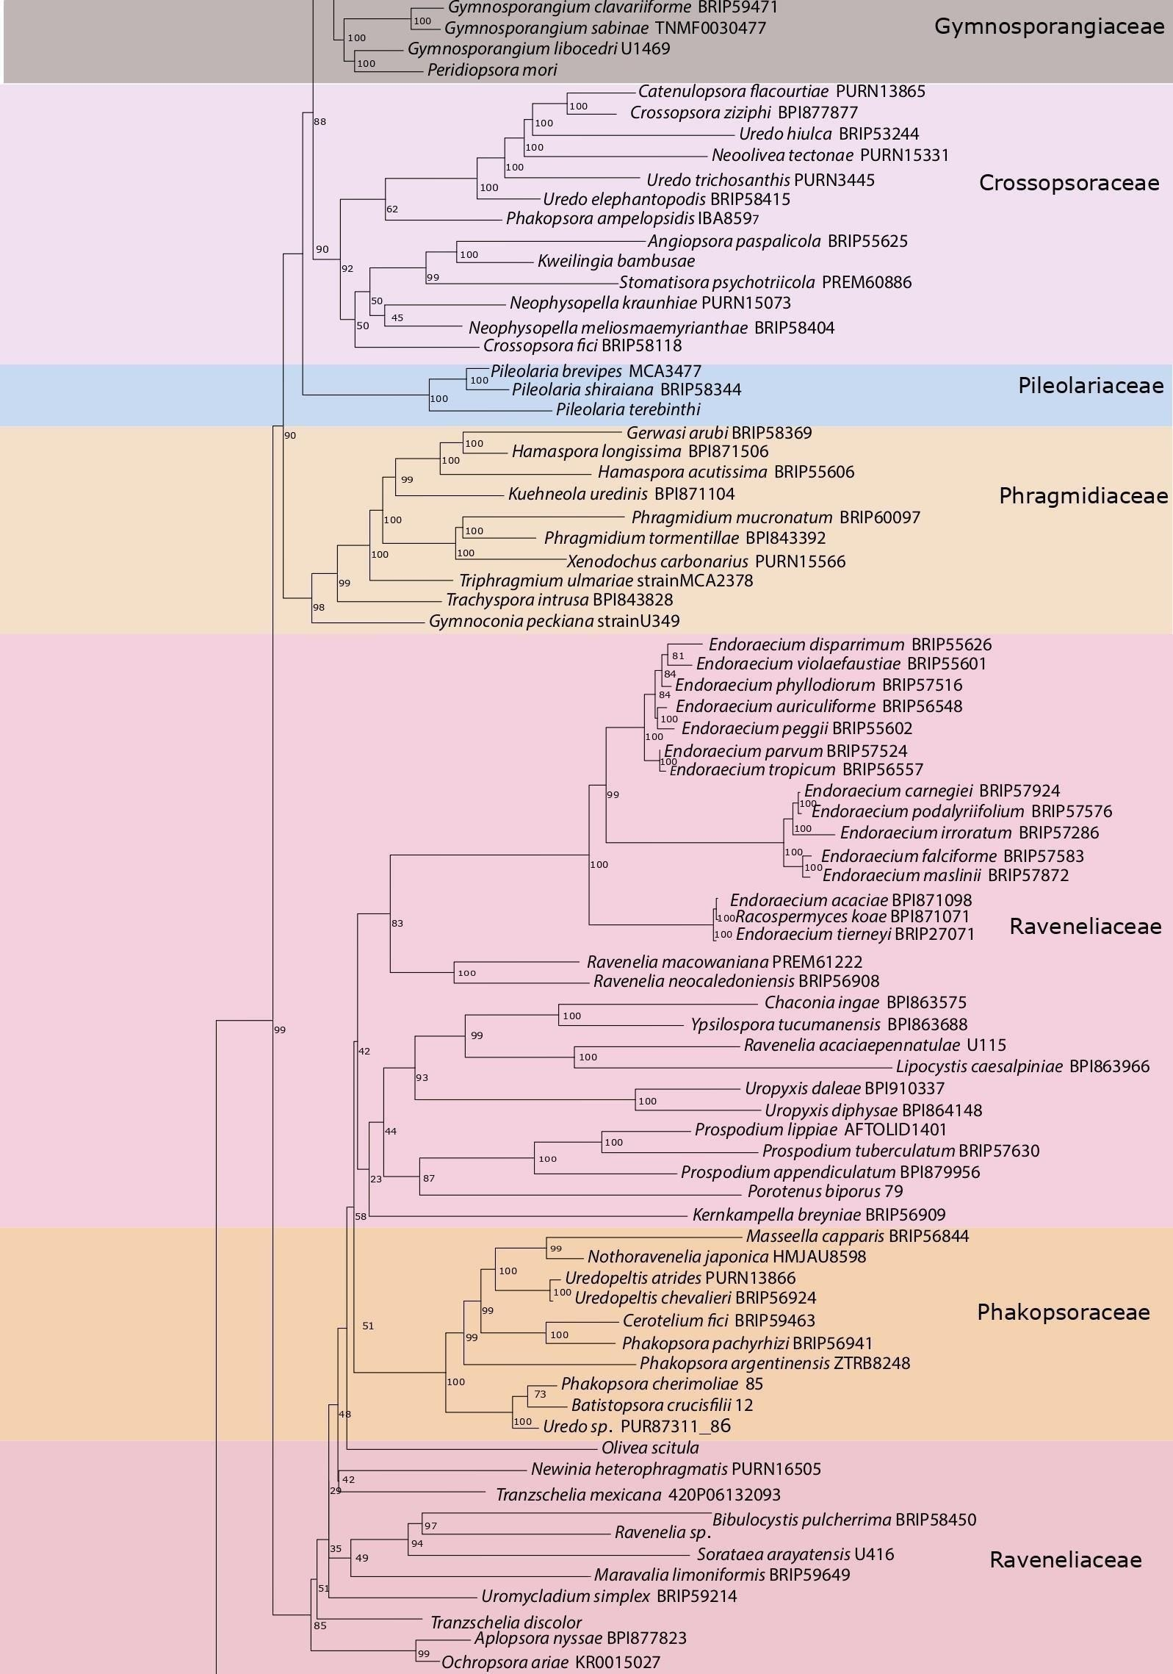

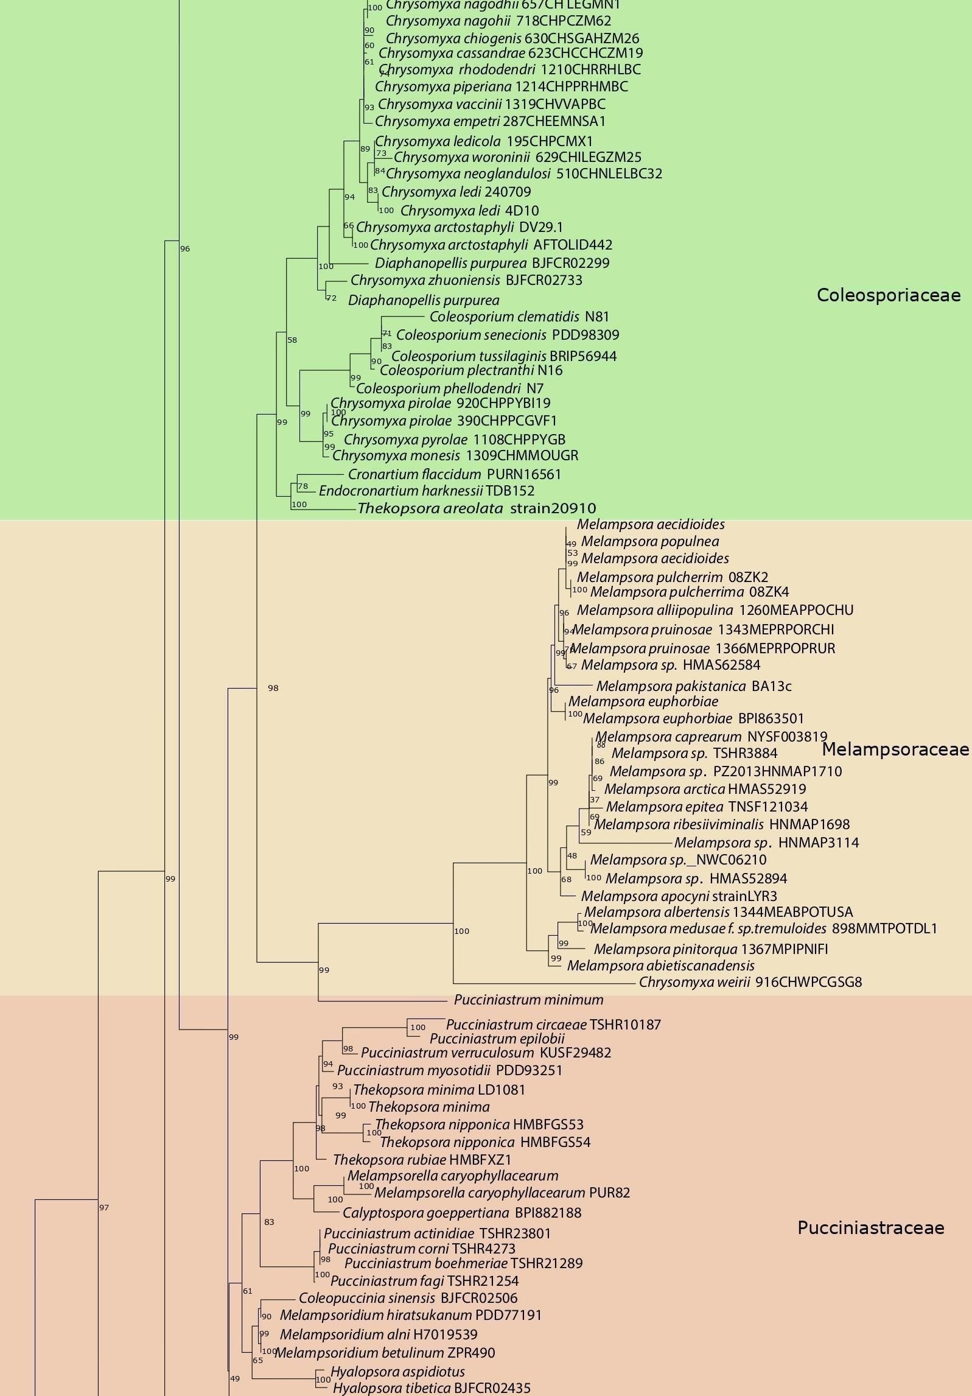

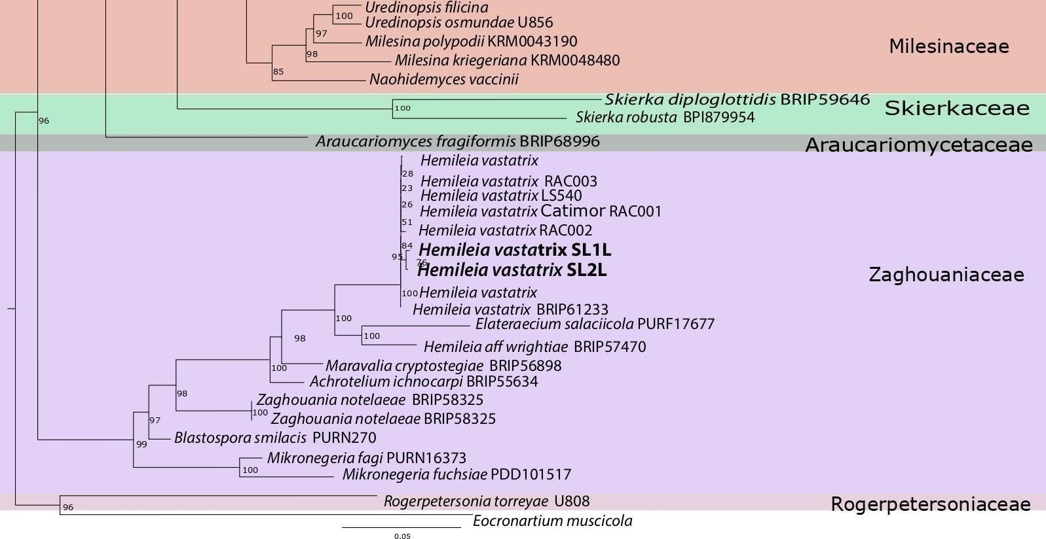

**Fig 4.5** - Phylogram resulted from combined LSU, SSU and COX3 specices of order Pucciniales using maximum likelihood method. Isolated *Hemeleia vastatrix SL1L and SL2L* in the study are named in bold font.

The phylogenetic tree constructed reveals a number of significant clades: Pucciniaceae, Sphaerophragmiaceae, Phragmidiaceae, Raveneliaceae, Phakopsoraceae, Melampsoraceae, Zaghouaniaceae, within the order Pucciniales, based on their evolutionary relationships. Pucciniaceae is one of the large and most diverse clade in the tree, containing numerous genera including *Puccinia*, *Uromyces*, and *Gymnosporangium*. Most of the genera exhibits high bootstrap support (≥70%), affirming its closely relationship in nature.

Bootstrap Values: High support at major nodes indicates a strong phylogenetic signal for most genera, reinforcing the evolutionary coherence of Pucciniaceae.

Phakopsoraceae includes rust fungi like *Phakopsora pachyrhizi* (Asian soybean rust). It has moderate bootstrap support (70-85%) at key nodes. Genera diversity is limited compared to Pucciniaceae but includes economically important pathogens. Moderate bootstrap support suggests variability in phylogenetic resolution, possibly due to genetic divergence within the family.

According to the results of the phylogenetic analysis, the family Raveneliaceae represents the biggest and most diverse clade in the tree. It includes Dayspora, Endoracium, and Ravenelia with related genera. In the tree, the bootstrap supports ranged from high (≥ 85%) for some subclades to weak (< 70%) for others, indicating the remaining relationships unresolved and/or potential taxonomic reclassifications. This may point to polyphyly or paraphyly, which needs further taxonomic investigation.

Clades like Melampsoraceae (varying bootstrap levels) also highlight the presence of monophyletic and possibly polyphyletic lineages, illustrating complexities in rust fungi evolution. The genus Melamspora was identified as the prominent genus in this clade with higher bootstrap support.

All the species belongs to Chrysoma and Colesporium are cluster together in a same clade inferring their evolutionary relationship within the Coleosporiaceae family.

The samples of *Hemileia vastatrix* SL1L and SL2L, representing coffee rust, clustered together within the Zaghouaniaceae clade. This clade highly supported with values ≥90% at the defining node which demonstrate close evolutionary relationships with other Hemileia species, confirming its taxonomic placement. These results align with the known phylogenetic position of *Hemileia vastatrix* as a prominent member of Zaghouaniaceae.

## 4.4 Divergence time analysis

Divergence times were estimated by a secondary calibration approach (Renner, 2005), which is a common practice in fungal studies due to the generally limited availability of fossil records for setting internal calibration points (Matheny *et al*., 2009; Floudas *et al.,* 2012; Wilson *et al*., 2012). A molecular clock model was implemented by including fossil records or previously published divergence times as calibration points. Molecular dating analyses were performed using the program BEAST v1.10.4 (Drummond *et al*., 2006; Drummond and Rambaut, 2007) based on multi- gene loci data (LSU, SSU, COX3) and considering a secondary calibration nodes (Stem of Pucciniales, Mean 176 MYA, SD 20 MYA, Yule.birthRate model, 40,000,000 generations, 1,000 sample frequency). This analysis provides the estimated times to the most recent common ancestor for each family, their relative diversification rates, and highlights the evolutionary timelines of specific samples, such as SL1Land SL2L *Hemileia vastatrix*, within the Zaghouniaceae family.

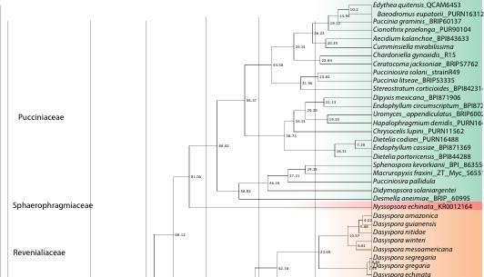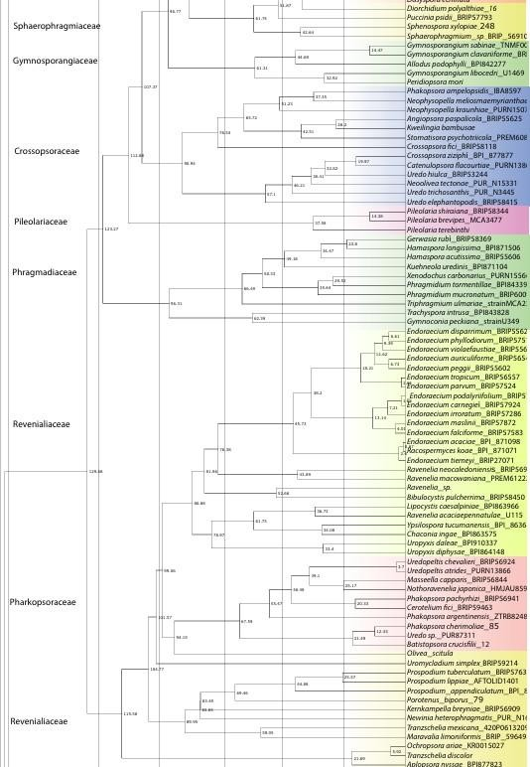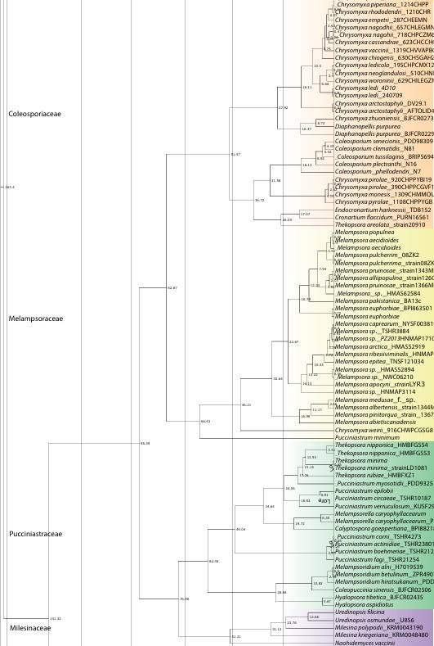

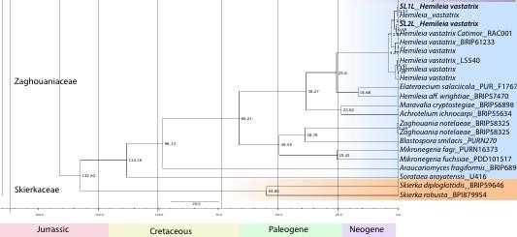

**Fig 4.6** – Divergence time estimation of order Pucciniales using BEAST v1.10.4 (Drummond *et al*., 2006; Drummond and Rambaut 2007) programme based on multi-gene loci data and considering secondary calibration nodes analysis. The evolutionary timelines of specific samples, such as SL1L and SL2L *Hemileia vastatrix*, within the Zaghouniaceae family is mentioned in bold font.

The family origin in the Pucciniales evolved during a different time with different ecological conditions and host dynamics. Some families are more distinct in diverging patterns among others like Pucciniaceae, Ravenliaceae, Coleosporiaceae, Phakopsoraceae Melampsorineae, and Zaghouniaceae.

The Pucciniales is one of the largest orders; the early diverging families of Milesinaceae, and subfamilies of Ravenliaceae actually occurred in the Late Jurassic to Early Cretaceous, approximately 140-145 million years ago for Milesinaceae, and 130 million years ago for some species in Ravenliaceae. These had evolved during times when gymnosperms dominated terrestrial ecosystems and provided ecological niches for fungi.

Milesinaceae and Ravenliaceae most likely developed a strong ecological association with ancient gymnosperms such as conifers, which were common during this period. The persistence of the family to subsequent periods attests to the adaptation ability of this taxon in the stable niches.

As one of the earliest diverging lineages, Milesinaceae and Ravenliaceae provide a critical insight into early stages of fungal-plant co-evolution.

The radiation of angiosperms took place during the Mid-Cretaceous period, ~95–125 Ma, and opened up new ecological opportunities for fungi. Because of that, many rust fungi families have evolved in this era. Crossopsoraceae, Phakospsoraceae, Raveneliaceae, Coleosporiaceae, Zaghouniacea and Sphaerophragmiaceae families diverged during this time, reflecting the influence of flowering plants on fungal evolution.

The Raveneliaceae emerged around 110–125 Ma to specialize in flowering plants of tropical and subtropical environments. Its evolution seems to be more directly linked with the geographic and ecological expansion of angiosperms, allowing more host-specific specialization that facilitatedfurther diversification within this family. By aligning its ecological strategies with angiosperm- dominated ecosystems, the Raveneliaceae exemplifies fungal evolution shaped by plant radiation.

In contrast, Sphaerophragmiaceae, which originated some 95–100 Ma, exhibits narrower host specificity. This family is representative of the ecological constraints that hampered its diversification compared to families such as Raveneliaceae and Coleosporiaceae. The dependence of Sphaerophragmiaceae on a limited range of angiosperm hosts depicts selective pressures guiding fungal adaptation during the Mid-Cretaceous radiation.

Crossopsoraceae and Phragmidiaceae, diverging around 90-95 Ma, diversified as flowering plants became dominant in terrestrial ecosystems. This family’s emergence corresponds to the later stages of angiosperm diversification, suggesting adaptations to cooler climates and evolving plant communities. Host-pathogen interactions played a significant role in driving the diversification of Crossopsoraceae and Phragmidiaceae, particularly in ecosystems dominated by temperate flowering plants.

These make the Zaghouniaceae family an intriguing case of evolutionary timing, especially with the diversification of SL1L and SL2L *Hemileia vastatrix*. The familial diversification began ca. 110-115 Ma, during the mid Cretaceous periods. This timing corresponds to major evolutionary transitions, including the spread of flowering plants and the subsequent co-evolution of plant- pathogen interactions.

This divergence between SL1L and SL2L *Hemileia vastatrix* occurred more recently, about 10–15 Ma. Thus, this reflects the relatively recent diversification within the lineage, with most of the divergences probably under environmental and ecological pressures. During the Miocene epoch,

with the general cooling trend and geographical spreading of Coffea, the specialization of those fungal samples reached the best scenario ever.

SL1L and SL2L, on an evolutionary perspective, are close relatives, judged from their phylogenetic proximity in the tree. This lineage likely derived from a common ancestor that had already acquired the infective capacity of early species in *Coffea*. Following divergence, these isolates appear to have independently developed distinctive pathogenic features related to local adaptation in different Coffea varieties. High host fidelity among Zaghouniaceae suggests co- evolutionary dynamics may be key in these fungi-plant relationships.

Families such as the Pucciniaceae, Melampsorineae, and Phakopsoraceae have evolved during the Late Cretaceous to Early Paleogene (ca. 60–90 Ma) to adapt to temperate climates and specialized angiosperm hosts.

The family Pucciniaceae emerged ~80 million years ago, as inferred from its time to the most recent common ancestor. This evolutionary milestone coincided with the late-cretaceous period-a time when angiosperm plants were rapidly diversifying. The diversification of Pucciniaceae appears closely linked to host-specific interactions with a wide range of angiosperms that likely drove its radiation into the diverse forms we observe today.

On the other hand, the median tMRCA estimate for Melampsorineae is around 65-70 Ma, corresponding to divergence in the Late Cretaceous when both ancient gymnosperms and early angiosperms diversified. Their evolutionary path has corresponded with their specializing on pinaceous hosts during the aecial life stage. This earlier date of divergence would mirror an ecological niche taking advantage of the prevailing gymnosperms and their interaction with the then-developing angiosperm lineages.

The Phakopsoraceae diverged in the transition from the Late Cretaceous to the Early Paleogene, approximately 60-70 Ma. This family is associated with the expansion of leguminous plants during that time. Thus, the evolution of the family Phakopsoraceae was toward host specialization due to the changing climates and ecosystems of the Cenozoic. Its relatively young divergence underlines the dynamic nature of fungal evolution in response to environmental changes and availability of hosts.

Of these, the youngest family, the Coleosporiaceae, which diverged around 50-55 Ma, most likely evolved through host shifts between gymnosperms and early angiosperms. This family, in a way, reflects an optimum compromise between ecological generalization and specialization that has

enabled it to persist on multiple host lineages. Paleogene diversification underlines the role of this family in exploiting the emerging dominance of flowering plants.

This family is remarkable because of its specificity regarding aecial and telial hosts, with co- evolutionary dynamics with angiosperms; indeed, its evolutionary trajectory matches the global spread of flowering plants, facilitating its ecological success.

# 5.0 DISCUSSION

Understanding the evolutionary history and ancestral traits of *Pucciniales*, mainly focusing on the morpho-molecular characteristics of coffee rust in Sri Lanka, is timely needed as coffee rust (*Hemileia vastatrix*) has significant historical and economic importance. Therefore, this research will be a valuable contribution to plant pathology and evolutionary biology. Sri Lanka holds a unique place in the history of coffee rust, as it was the site of the first recorded outbreak of *Hemileia vastatri* (Talhinhas *et al.,* 2014; Talhinhas *et al.,* 2017). Despite this, very little research has been done on the evolutionary aspect of this pathogen with Sri Lankan samples. Though there are various studies concerning evolutionary analysis, Aime (2006), Beenken and Wood (2015), McTaggart *et al*., (2016), Aime *et al*., (2017, 2018), Beenken (2017), and Souza *et al*., (2018), the importance of the present study is that it uses Sri Lankan samples and includes 227 taxa to get more accurate results. This study will fill a significant knowledge gap by analyzing the evolutionary pathway and molecular characteristics of coffee rust. The economic significance of *H. vastatrix* is another key driver of this research, as the pathogen has caused severe losses in coffee production worldwide (Henderson, 2020; Ramírez-Rodríguez *et al*., 2020). Its ability to evolve and adapt makes it a persistent challenge for growers (Castillo *et al*., 2020; Henderson, 2020). By reconstructing its evolutionary history and ancestral traits, this study contributes to developing better management strategies and selecting resistant coffee varieties. Additionally, the morpho-molecular characterization bridges the gap between physical traits and genetic data, offering a comprehensive understanding of its diversity and evolutionary relationships (Aime *et al*., 2017; Gamarra *et al*., 2021).

For this study, coffee rust samples were collected from the Matale and Balangoda districts in Sri Lanka. While the disease is found in other regions, these two districts were chosen because of their importance in coffee cultivation and their ideal conditions for the growth of *Hemileia vastatrix*. The high elevation

and humidity in these areas create a perfect environment for the pathogen to thrive, as documented in

previous studies (Avelino *et al*., 2006; McCook, 2019; Antonio *et al*., 2021). These favorable conditions support the persistence and spread of coffee rust, making them ideal locations for sample collection. However, sample collection held several challenges. Among the many was the heavy rainfall the region experienced. Rain and wind can dislodge urediniospores of *H. vastatrix* from infected leaves thereby reducing the viability of samples for collection. Previous studies have identified wind and rain as key environmental factors that either disperse or remove rust spores, therefore influencing the longevity of the fungal spores on coffee plants (Geagea *et al*.,1999; Pale-Ezquivel *et al*., 2023). The timing of the sample was, therefore, chosen to align with the best chance of collecting enough representative material. Morphological and molecular analysis of the coffee rust fungi was highly problematic because of its biotrophic nature. Biotrophy refers to a condition whereby a pathogen depends on living host cells for growth and reproduction. Unlike necrotrophic fungi that can be grown in synthetic media, the biotrophic fungi, *Hemileia vastatrix,* cannot be maintained under artificial culture conditions. This has made it impossible to identify mycelial structures in vitro or to preserve samples for longer periods.

When it came to molecular analysis, the biotrophic nature of the fungi that cause rust diseases in coffee imposed additional challenges in DNA extraction. One of the biggest issues present in this study was microparasites related to *H. vastatrix*. Because these fungi are a biotrophic type of pathogen that cannot be grown on an artificial medium a pure isolate is not obtainable. With this constraint comes the ability of other organisms, including microparasites that derive their nourishment from rust fungi. The presence of these microparasites has adverse effects on carrying out molecular work, for instance, through contaminating DNA extractions with its own, yielding unwanted DNA sequencing.

In this investigation, attempts to sequence the samples revealed a collection of microparasites- namely *Epiphytum sp., Lecanicillium psalliotae, Cephalosporium curtipes*, and *Corniculantispora psalliotae-* instead of rust fungi. Such contaminating agents complicated the molecular analysis, as careful isolation

of samples should have been undertaken. Indeed, several studies related to rust fungi faced similar

situations (Aime *et al*., 2018; Talhinhas *et al*., 2017), in which careful sample preparation methods have been developed or should be developed to minimize contamination.

This may call for future studies to put more emphasis on the careful isolation of urediniospores directly from the leaves onto which the infection occurs, prior to DNA extraction. Advanced microscopy and microdissection techniques may facilitate obtaining purer samples. The samples, after the process of isolation, were preserved in absolute ethanol to prevent any microbial growth or genetic degradation.

Microscopic examination at 40× magnification allowed for detailed observation of key morphological traits of coffee rust samples, such as spore size, shape, and wall ornamentation which was essential for confirming species identity and comparing morphological variations across samples. The morphological analysis of *Hemileia vastatrix* urediniospores obtained from Matale and Balangoda showed similar characteristics to previous studies. These spores are broadly ellipsoidal to elliptical, with half-smooth and half-rough surfaces, containing carotenoid lipid granules responsible for their yellow-orange pigmentation. No significant morphological differences were observed between samples from the two districts, even though there was a difference in environmental conditions.

Both samples from Matale and Balangoda had thick-walled urediniospores with echinulae slightly varying both in size and spacing. The surfaces in the Matale sample were finely echinulate, having about 0.2-0.5 µm at the base and with an average distance of about 1.3 µm at the apices. In contrast, the Balangoda samples were distantly echinulate at 0.5–0.8 µm at the base and separated at 2.1 µm average at the apex. Minor variation in spore ornamentation across populations may stem from habitat differences in elevation and humidity: elevated elevation and greater humidity are understood to promote the thickening of spores in rust fungi with resultant echinulation (Antonio *et al*., 2021; Talhinhas *et al*., 2017).

Comparing these results with the literature, the dimensions of urediniospores and their wall thickness agree with the descriptions by Gamarra *et al.,* 2021; Pelayo-Sánchez *et al*., 2025 and Talhinhas *et al*., 2017. The minor ornamentation differences suggest that environmental conditions, such as microclimatic variations in the same sampling site can influence morphological traits. Besides, the absence of germ pores and paraphyses from both samples agrees with earlier studies on *H. Vastatrix* (Pelayo-Sánchez *et al*., 2025), further establishing the stability of these morphological characteristics in different geographic locations.

Conventional methods of DNA extraction, such as the CTAB protocol, do not work on the rigid structure of the walls of the spores. Spores of *H. vastatrix* have thick, melanized cell walls that provide little access to efficient DNA extraction, leading to low yields and poor-quality genomic material. This challenge aside, a DNA extraction kit should afford efficient lysis of rust spores to guarantee high DNA qualities that may go up to the sequencing reaction.

With these limitations, direct sequencing methods were employed for molecular analysis. Unlike other fungi, where cultures can be maintained for continuous DNA extraction, the inability to culture *H. vastatrix* necessitated immediate DNA extraction from freshly collected urediniospores. In this approach of direct sequencing, the correct identification of genetic markers and phylogenetic placement of the coffee rust pathogen was possible.

In this study, each step in DNA extraction was aimed at maximizing sample purity and quality. Pre- treatment of spores with a 10% Chlorox solution containing Tween 20 removed superficial contaminants, including plant debris and superficial microbes, without affecting fungal DNA. Incubation at 60°C followed by centrifugation ensured thorough cleaning, which is essential for high- quality DNA. The observation of spores with a light microscope after each washing confirmed the effectiveness of this cleaning step. Rust fungi possess thick-walled spores; DNA extraction is difficult

from such spores. A sorbitol buffer was used along with lyticase or zymolase, which helped to digest the fungal cell wall for the freeing of the DNA. Sequential centrifugation and washing removed cellular debris and proteins and hence guaranteed the purity of the DNA extracted. Final elution with preheated Buffer BE or TE significantly increased DNA yield and stability, which is essential for high-quality PCR amplifications. LSU and SSU regions were the general genetic markers that allowed the identification and phylogenetic placement of *H. vastatrix* by PCR amplification (Aime *et al*., 2017). The use of pathogen-specific primers and optimized DNA extraction protocols for rust fungi may improve the chances of successful sequencing. The use of rust-specific DNA extraction kits, as was the case in this study, remains an important step in minimizing contamination with non-target microorganisms.

Phylogenetic analysis for the present study was done by employing the ML method on three gene regions, namely LSU, SSU, and COX3, and gives a sound framework for inferring evolutionary relationships within Pucciniales. This study has incorporated 227 rust fungi species, including two Sri Lankan *Hemileia vastatrix* samples, SL1L and SL2L. This analysis, including many taxa, makes it one of the most comprehensive studies to date, reinforcing and refining previous phylogenetic assessments of rust fungi.

The ML tree from the combined loci generally agreed with previous studies that relied on more limited taxon and locus sampling, such as Aime (2006), Beenken and Wood (2015), McTaggart *et al*., (2016), Aime *et al*. (2017, 2018), Beenken (2017), and Souza *et al.,* (2018). The consistency of results supports the robustness of the phylogenetic framework in Pucciniales and confirms the major rust fungi family’s evolutionary placement. A more updated classification of rust fungi was recently given by Aime and McTaggart (2021), proposing an updated higher-rank classification to which this study contributes to the refinement of these relationships via extensive taxon sampling.

Clades well supported within the resulting phylogenetic tree were retrieved corresponding to most established families and genera, locating *H. vastatrix* within the clade Zaghouaniaceae. The high bootstrap support (≥90%) at the defining node of this clade confirms its strong evolutionary relationship with other *Hemileia* species. The placement of Sri Lankan *H. vastatrix* within this framework is particularly significant, as this species represents the first recorded pathogenic rust fungus in the world. The given study gives the necessary phylogenetic confirmation for its position in Pucciniales, thus helping to fix its taxonomic and evolutionary status.

A comparison with previously published studies, such as that by McTaggart *et al*., (2016), presents similar phylogenetic relationships and confirms that host jumps, and co-evolutionary events have deeply influenced the diversity of Pucciniales (McTaggart *et al.*, 2016). McTaggart *et al*., 2016 believed that rust fungi diverged because of a mix of co-evolution with hosts and host jumps, which in turn contributed to their diversification. Its placing within the Zaghouaniaceae clade verifies previous views on the recent divergence of rust fungi on angiosperms rather than its ancestral association with ferns and gymnosperms, as earlier perceived by McTaggart *et al*., 2016.

Another important observation of the research is the confirmation of monophyly among the major families of rust fungi. Indeed, the family Pucciniaceae, which houses economically very important genera such as Puccinia and Uromyces, is strongly supported with a high bootstrap value of ≥ 70%, confirming the evolutionary coherence of this family. In turn, the clade Phakopsoraceae, to which *Phakopsora pachyrhizi* or Asian soybean rust belongs, was moderately supported with a 70-85% bootstrap value, thus reflecting partial genetic divergence within the family.

Surprisingly, this study revealed some conflicts with the previous phylogenetic classification. While McTaggart *et al*., (2016) placed *Puccinia psidii* within Raveneliaceae, our analysis placed it closer to Sphaerophragmiaceae, consistent with results from Aime & McTaggart, 2021. That means there is a

possibility of taxonomic reclassification between these groups and further illustrates the complexity of rust fungi evolution.

Further confirmation of *Hemileia vastatrix's* position within the Zaghouaniaceae clade, as evidenced by the high-bootstrap-supported clustering within the clade, confirms the taxonomic positioning. However, some internal nodes in this clade are only moderately supported to show that the genetic variation of *Hemileia* species may, therefore, need further investigation. The Melampsoraceae clade results indicated paraphyletic and polyphyletic lineages due to continuing evolutionary transitions that are likely to undergo further classification modification.

The phylogenetic results obtained in this study support the recognized hypothesis on the evolutionary history of rust fungi while pointing out further investigation required. The inclusion of Sri Lankan *H. vastatrix* into the global phylogenetic framework provides insight into its evolutionary path, supporting its close relationship with other *Hemileia* species. These findings contribute to the wider knowledge of the evolution of rust fungi and indicate the importance of molecular phylogenetics in resolving uncertainties in taxonomy.

These results of divergence time analyses in the current study are crucial to understanding the evolutionary history, especially its co-evolutionary process with plant hosts. As estimated, Pucciniales began to radiate at around 163 MA, coinciding with the origin of angiosperms. The divergence time coincides with the hypothesis that Pucciniales co-evolved with their plant hosts during this crucial period and hence could indicate an evolutionary link between rust fungi and the diversification of flowering plants.

Our estimates of crown age for Pucciniales (around 176 MA) match the most recent estimate by Aime *et al*. (2018). This study also supports the correlation of rust fungi diversification with the evolution of angiosperms. However, McTaggart *et al*., (2016) came up with a much younger age for Pucciniales and

estimated a mean divergence at around 113-115 MA. The large discrepancy between these estimates is likely due to differences in their calibration methods. Whereas Aime *et al*., (2018) estimated the ages of fungi using external fossil calibration points, McTaggart *et al*., (2016) made internal calibrations based on host plant divergence times. Fossil calibration generally yields older divergence estimates, whereas host-based calibrations often yield substantially younger ages owing to the dynamic nature of host-pathogen interactions.

Our analysis shows the divergence of the family Zaghouaniaceae, comprising *Hemileia vastatrix*, from other rust fungi at roughly 132 MA during the early Cretaceous, the beginning of the phase of rapid angiosperm diversification. Therefore, this suggests a close relation to the period of evolutionary change and adaptation that rust fungi seem to have followed toward new plant hosts. Intriguingly, within the family Zaghouaniaceae, *H. vastatrix* diversified about 107 million years later, which would support the fact that this fungus had recently adapted to its current host, Coffea spp.

These results confirm previous findings that many rust fungi families diversified during the Cretaceous, coinciding with the rapid radiation of angiosperms (Aime *et al*., 2018). The co-diversification hypothesis is further supported by molecular dating studies that suggest host shifts played a significant role in the speciation of rust fungi (McTaggart *et al*., 2016). Although evidence of co-evolution is apparent in some rust fungi groups, McTaggart *et al*., (2016) have suggested that host jumps are the primary driving forces behind rust fungi diversification. Our results indicate that, most likely, both processes played a role in the evolutionary success of rust fungi, depending on specific host-pathogen interactions.

More specifically, the overall pattern of rust fungi diversification timing in our study coincides with the genomic estimates of Basidiomycota (Floudas *et al*., 2012). This lends credibility to our estimates of divergence time and gives an indication of wider evolutionary trends within fungal lineages.

Furthermore, our results were congruent with the estimated times of diversification of major host lineages, such as the split between gymnosperms and angiosperms (Magallon and Castillo, 2009).

Despite these consistencies, some deviations were observed. Our study estimated an earlier divergence for Pucciniales compared to McTaggart *et al*., (2016), highlighting the impact of calibration choices on molecular dating. Moreover, while Aime *et al*., (2018) suggested that early-diverging Pucciniales lineages were associated with gymnosperms, our results indicate that core rust fungi began diversifying alongside angiosperms. These observations are consistent with the hypothesis that rust fungi originated on gymnosperms and later switched to angiosperm hosts; however, it is noteworthy to mention that further study on this evolutionary pathway is recommended.

# 6.0 RECOMMENDATIONS

Future research on *Pucciniales* and the evolution of coffee rust should focus on several key areas. Expanding sample collection to include more regions in Sri Lanka would provide a broader understanding of genetic diversity and environmental influences on the pathogen. Regional variations may contribute to pathogen adaptability, and a more comprehensive dataset would offer deeper insights into its evolution and host interactions.

Improving sample isolation methods is also essential to prevent contamination by microparasites. Since

*H. vastatrix* is a biotrophic fungus that cannot be cultured in pure form, advanced techniques like microdissection and laser capture microscopy will be necessary for precise spore isolation. Additionally, using pathogen-specific primers and optimized DNA extraction methods will ensure high- quality genomic material for sequencing and molecular studies.

Morphological analysis should include studies on spore viability under different environmental conditions, such as temperature, humidity, and UV exposure. These factors may influence the longevity of spores and their ability to infect hosts. Furthermore, using advanced imaging techniques like scanning electron microscopy (SEM) and confocal laser scanning microscopy (CLSM) would allow for detailed characterization of spores.

Incorporating additional genetic markers, such as whole-genome sequencing and transcriptomic data, will refine phylogenetic relationships and improve divergence time estimates. More advanced molecular clock models and fossil calibration methods can further enhance the accuracy of evolutionary timelines. By addressing these research gaps, a better understanding of *H. vastatrix* evolution and adaptability can be achieved, ultimately aiding in developing effective disease management strategies.

* Morphological analysis of *Hemileia vastatrix* confirmed its ellipsoidal shape, thick-walled urediniospores, and characteristic echinulation patterns, consistent with previous records.
* No significant morphological differences were observed between the Matale and Balangoda samples, suggesting no variation in response to fluctuating environmental conditions.
* Phylogenetic analysis based on three genetic markers (LSU, SSU, and COX3) revealed the evolutionary relationships among 225 species from 18 families of the order Pucciniales, confirming the placement of *H. vastatrix* within the family Zaghouaniaceae.
* The estimated divergence time for Pucciniales was approximately 163 million years ago, aligning with the rise of angiosperms and supporting the hypothesis of co-evolution between rust fungi and their host plants.
* The Zaghouaniaceae family, including *H. vastatrix*, is estimated to have diverged around 132 million years ago during the early Cretaceous period, corresponding with the initial major diversification of angiosperms.
* The divergence time for *H. vastatrix* within the family was estimated to be approximately 107 million years later, indicating its recent adaptation to coffee species.
* These findings bolster the hypothesis that rust fungi evolved in response to the diversification of their host plants, with both host jumps and co-evolution playing significant roles in their evolutionary history.

**Adepoju, A.F., Adenuga, O.O., Mapayi, E.F., Olaniyi, O.O. and Adepoju, F.A.**, 2017. Coffee: botany, distribution, diversity, chemical composition and its management. Journal Agriculture and Veterinary Science, 10(7), pp.57-62.

**Aime, M.C.** 2006**.** Toward resolving family-level relationships in rust fungi (Uredinales). *Mycoscience*, *47*(3), pp.112-122.

**Aime, M.C., Matheny, P.B., Henk, D.A., Frieders, E.M., Nilsson, R.H., Piepenbring, M., McLaughlin, D.J., Szabo, L.J., Begerow, D., Sampaio, J.P. and Bauer, R.** 2006. An overview of the higher- level classification of Pucciniomycotina based on combined analyses of nuclear large and small subunit rDNA sequences. *Mycologia*, *98*(6), pp.896-905.

**Aime, M.C., McTaggart, A.R., Mondo, S.J. and Duplessis, S.** 2017. Phylogenetics and phylogenomics of rust fungi. *Advances in genetics*, *100*, pp.267-307.

**Aime, M.C., Bell, C.D. and Wilson, A.W.** 2018. Deconstructing the evolutionary complexity between rust fungi (Pucciniales) and their plant hosts. *Studies in Mycology*, *89*(1), pp.143-152.

**Aime, M.C. and McTaggart, A.R.** 2021. A higher-rank classification for rust fungi, with notes on genera. *Fungal systematics and evolution*, *7*(1), pp.21-47.

**Alaei, H., De Backer, M., Nuytinck, J., Maes, M., Höfte, M. and Heungens, K.** 2009. Phylogenetic relationships of Puccinia horiana and other rust pathogens of Chrysanthemum× morifolium based on rDNA ITS sequence analysis. *Mycological Research*, *113*(6-7), pp.668-683.

**Almeida, J.R.D., Riaño Pachón, D.M., Franceschini, L.M., Santos, I.B.D., Ferrarezi, J.A., Andrade, P.A.M.D., Vitorello, C.B.M., Labate, C.A. and Verdi, M.C.Q.** 2021. Revealing the high variability on nonconserved core and mobile elements of Austropuccinia psidii and other rust mitochondrial genomes. *PLoS One*, *16*(3), pp.1-20.

**Anikster, Y., Szabo, L.J., Eilam, T., Manisterski, J., Koike, S.T. and Bushnell, W.R.** 2004. Morphology, life cycle biology, and DNA sequence analysis of rust fungi on garlic and chives from California. *Phytopathology*, *94*(6), pp.569-577.

**Antonio, M.A.M., Martínez, G.M.S., López, A.V., Ortiz, G.R., Trejo, S.L. and Hidalgo, E.C.** 2021. Uredospore germination of Hemileia vastatrix and its inhibition by the effect of plant extracts in vitro. *Ciencia e investigación agraria: revista latinoamericana de ciencias de la agricultura*, *48*(2), pp.108-114.

**Avasthi, S., Gautam, A.K., Niranjan, M., Verma, R.K., Karunarathna, S.C., Kumar, A. and Suwannarach, N.** 2023. Insights into diversity, distribution, and systematics of rust genus Puccinia. *Journal of Fungi*, *9*(6), p.639.

**Avelino, J., Zelaya, H., Merlo, A., Pineda, A., Ordóñez, M. and Savary, S.** 2006. The intensity of a coffee rust epidemic is dependent on production situations. *Ecological modelling*, *197*(3-4), pp.431- 447.

**Beddow, J.M., Pardey, P.G., Chai, Y., Hurley, T.M., Kriticos, D.J., Braun, H.J., Park, R.F., Cuddy, W.S. and Yonow, T.** 2015. Research investment implications of shifts in the global geography of wheat stripe rust. *Nature Plants*, *1*(10), pp.1-5.

**Beenken, L**. 2014. Pucciniales on Annona (Annonaceae) with special focus on the genus Phakopsora. Mycological Progress, 13, pp.791-809.

**Beenken, L. and Wood, A.R.**, 2015. Puccorchidium and Sphenorchidium, two new genera of Pucciniales on Annonaceae related to Puccinia psidii and the genus Dasyspora. Mycological Progress, 14, pp.1-13.

**Beenken, L.** 2017. Austropuccinia: a new genus name for the myrtle rust Puccinia psidii placed within the redefined family Sphaerophragmiaceae (Pucciniales). *Phytotaxa*, *297*(1), pp.53-61.

**Bolton, M.D., Kolmer, J.A. and Garvin, D.F.** 2008. Wheat leaf rust caused by *Puccinia triticina*. *Molecular plant pathology*, *9*(5), pp.563-575.

**Burley, J.** 2004. *Encyclopedia of forest sciences*. Academic Press.

**Caicedo, B.L.C**. 2014. Diseases of Coffee with Particular Reference to Those Affecting Stems and Roots in Colombia (Doctoral dissertation, University of Pretoria (South Africa)).

**Carefoot, G.L. and Sprott, E.R.** 1969. Famine on the wind. Plant disease and human history.

**Carnegie, A.J. and Pegg, G.S.** 2018. Lessons from the incursion of myrtle rust in Australia. *Annual review of Phytopathology*, *56*(1), pp.457-478.

**Castillo, N.E.T., Melchor-Martínez, E.M., Sierra, J.S.O., Ramirez-Mendoza, R.A., Parra- Saldívar, R. and Iqbal, H.M.** 2020. Impact of climate change and early development of coffee rust– An overview of control strategies to preserve organic cultivars in Mexico. *Science of the Total Environment*, *738*, p.140225.

**Cavalli-Sforza, L.L. and Edwards, A.W.** 1967. Phylogenetic analysis. Models and estimation procedures. *American journal of human genetics*, *19*(3 Pt 1), p.233.

**Cerda, R., Avelino, J., Gary, C., Tixier, P., Lechevallier, E. and Allinne, C.**, 2017. Primary and secondary yield losses caused by pests and diseases: Assessment and modeling in coffee. PloS one, 12(1), p.e0169133.

**Cooper, A.J., Woods-Tör, A. and Holub, E.B**. 2002. Albugo candida (white rust) suppresses resistance to downy mildew pathogens in Arabidopsis thaliana.

**Cummins, G.B. and Hiratsuka, Y.** 2003. Illustrated genera of rust fungi.

therapeutics of the Uredi-nales.

**Cruz, A.F., Tsuji, G., Lima, A.A. and Blum, L.E.B.** 2015. Uredinia and further morphological and molecular confirmation of the rust fungus Uromyces hawksworthii on Loranthaceae from the Brazilian Cerrado.

**Doungsa-ard, C., McTaggart, A.R., Geering, A.D., Dalisay, T.U., Ray, J. and Shivas, R.G.** 2015. Uromycladium falcatarium sp. nov., the cause of gall rust on Paraserianthes falcataria in south-east Asia. *Australasian Plant Pathology*, *44*, pp.25-30.

**Demelash Teferi, D.T. and Kifle Belachew, K.B.** 2018. A review of coffee diseases research in Ethiopia.

**Duplessis, S., Cuomo, C.A., Lin, Y.C., Aerts, A., Tisserant, E., Veneault-Fourrey, C., Joly, D.L., Hacquard, S., Amselem, J., Cantarel, B.L. and Chiu, R.** 2011. Obligate biotrophy features unraveled by the genomic analysis of rust fungi. *Proceedings of the National Academy of Sciences*, *108*(22), pp.9166-9171.

**Dupre, S.I., Harvey, C.A. and Holland, M.B.** 2022. The impact of coffee leaf rust on migration by smallholder coffee farmers in Guatemala. *World Development*, *156*, p.105918.

**Drummond, A.J., Ho, S.Y.W., Phillips, M.J. and Rambaut, A.** 2006. Relaxed phylogenetics and dating with confidence. *PLoS biology*, *4*(5), p.e88.

**Drummond, A.J. and Rambaut, A.** 2007. BEAST: Bayesian evolutionary analysis by sampling trees. *BMC evolutionary biology*, *7*, pp.1-8.

**Edgar, R.C.** 2004. MUSCLE: multiple sequence alignment with high accuracy and high throughput. *Nucleic acids research*, *32*(5), pp.1792-1797.

**Feau, N., Vialle, A., Allaire, M., Maier, W. and Hamelin, R.C.** 2011. DNA barcoding in the rust genus Chrysomyxa and its implications for the phylogeny of the genus. *Mycologia*, *103*(6), pp.1250- 1266.

**Felsenstein, J.** 1983. Parsimony in systematics: biological and statistical issues. *Annual review of ecology and systematics*, *14*, pp.313-333.

**Fitch, W.M. and Margoliash, E.** 1967. Construction of phylogenetic trees: a method based on mutation distances as estimated from cytochrome c sequences is of general applicability. Science, 155(3760), pp.279-284.

**Floudas, D., Binder, M., Riley, R., Barry, K., Blanchette, R.A., Henrissat, B., Martínez, A.T., Otillar, R., Spatafora, J.W., Yadav, J.S. and Aerts, A.** 2012. The Paleozoic origin of enzymatic lignin decomposition reconstructed from 31 fungal genomes. *Science*, *336*(6089), pp.1715-1719.

**Gamarra Gamarra, D.P., Torres Suarez, G., Villar Quiñonez, C.M., McTaggart, A.R. and Carrasco Lozano, E.C.** 2021. Phylogenetic relationship of coffee leaf rust in the central jungle of Peru. *Acta Agronómica*, *70*(2), pp.155-162.

**Gautam, A.K., Avasthi, S., Verma, R.K., Devadatha, B., Jayawardena, R.S. and Sushma, R.K.** 2021. Indian Pucciniales: taxonomic outline with important descriptive notes. *Mycosphere*, *12*, pp.89- 162.

**Geagea, Huber and Sache** 1999. Dry‐dispersal and rain‐splash of brown (Puccinia recondita f. sp. tritici) and yellow (P. striiformis) rust spores from infected wheat leaves exposed to simulated raindrops. *Plant Pathology*, *48*(4), pp.472-482.

**Gichuru, E., Alwora, G., Gimase, J. and Kathurima, C.** 2021. Coffee leaf rust (Hemileia vastatrix) in Kenya—A review. *Agronomy*, *11*(12), p.2590.

**Gullino, M.L.** 2021. *Spores: Tulips with Fever, Rusty Coffee, Rotten Apples, Sad Oranges, Crazy Basil. Plant Diseases that Changed the World as Well as My Life*. Springer Nature.

**Hart, J.A.** 1988. Rust fungi and host plant coevolution: do primitive hosts harbor primitive parasites?. *Cladistics*, *4*(4), pp.339-366.

**Harvey, C.A., Pritts, A.A., Zwetsloot, M.J., Jansen, K., Pulleman, M.M., Armbrecht, I., Avelino, J., Barrera, J.F., Bunn, C., García, J.H. and Isaza, C**. 2021. Transformation of coffee-growing landscapes across Latin America. A review. *Agronomy for sustainable development*, *41*(5), p.62.

**Henderson, T.P.** 2020. Elite-led development and Mexico’s independent coffee organisations in the wake of the rust epidemic. *Third World Quarterly*, *41*(6), pp.1012-1029.

**Ho, C.Y., Henningsen, E.C., Chen, S.T., Ariyawansa, H.A., Nazareno, E.S., Sperschneider, J., Dodds, P.N., Riddle, J., Kianian, S.F., Figueroa, M. and Huang, Y.F.** 2024. Detection of oat crown rust disease in Taiwan (2019-2021). *bioRxiv*, pp.2024-03.

### Huerta-Espino, J., Singh, R.P. German, S., McCallum, B.D., Park, R.F., Chen, W.Q., Bhardwaj,

**S.C. and Goyeau, H.,** 2011. Global status of wheat leaf rust caused by Puccinia triticina. *Euphytica*, *179*, pp.143-160.

**Jin, Y., Szabo, L.J. and Carson, M.** 2010. Century-old mystery of Puccinia striiformis life history solved with the identification of Berberis as an alternate host. *Phytopathology*, *100*(5), pp.432-435.

**Kolmer, J.A., Ordonez, M.E. and Groth, J.V.** 2009. The rust fungi. *Encyclopedia of life sciences (ELS)*, *10*(9780470015902), p.a0021264.

**Koutouleas, A., Collinge, D.B. and Boa, E.** 2024. The coffee leaf rust pandemic: An ever‐present danger to coffee production. *Plant pathology*, *73*(3), pp.522-534.

**Lemessa, F., Abera, A., Adunga, G. and Garedew, W.** 2015. Association of mycoflora with coffee (Coffea arabica L.) beans at limmu coffee plantation, Southwestern Ethiopia. Plant Pathology Journal,

**Larget, B. and Simon, D.L.** 1999. Markov chain Monte Carlo algorithms for the Bayesian analysis of phylogenetic trees. *Molecular biology and evolution*, *16*(6), pp.750-759.

**Le, S.Q., Lartillot, N. and Gascuel, O.** 2008. Phylogenetic mixture models for proteins. *Philosophical Transactions of the Royal Society B: Biological Sciences*, *363*(1512), pp.3965-3976.

**Liu, M. and Hambleton, S.** 2010. Taxonomic study of stripe rust, Puccinia striiformis sensu lato, based on molecular and morphological evidence. *Fungal biology*, *114*(10), pp.881-899.

**Liu, M. and Hambleton, S.** 2013. Laying the foundation for a taxonomic review of Puccinia coronata sl in a phylogenetic context. *Mycological Progress*, *12*, pp.63-89.

### Lorrain, C., Marchal, C., Hacquard, S., Delaruelle, C., Pétrowski, J., Petre, B., Hecker, A., Frey,

**P. and Duplessis, S.** 2018. The rust fungus Melampsora larici-populina expresses a conserved genetic program and distinct sets of secreted protein genes during infection of its two host plants, larch and poplar. *Molecular plant-microbe interactions*, *31*(7), pp.695-706.

### Lu, L., Tibpromma, S., Karunarathna, S.C., Jayawardena, R.S., Lumyong, S., Xu, J. and Hyde,

**K.D.** 2022. Comprehensive review of fungi on coffee. *Pathogens*, *11*(4), p.411.

**Magallón, S. and Castillo, A.** 2009. Angiosperm diversification through time. *American journal of botany*, *96*(1), pp.349-365.

**Maier, W., Begerow, D., Weiß, M. and Oberwinkler, F.** 2003. Phylogeny of the rust fungi: an approach using nuclear large subunit ribosomal DNA sequences. *Canadian Journal of Botany*, *81*(1), pp.12-23.

**Maier, W., McTaggart, A.R., Roux, J. and Wingfield, M.J.** 2016. Phakopsora myrtacearum sp. nov., a newly described rust (Pucciniales) on eucalypts in eastern and southern Africa. Plant Pathology, 65(2), pp.189-195.

**Matheny, P.B., Aime, M.C., Bougher, N.L., Buyck, B., Desjardin, D.E., Horak, E., Kropp, B.R., Lodge, D.J., Soytong, K., Trappe, J.M. and Hibbett, D.S.** 2009. Out of the Palaeotropics? Historical biogeography and diversification of the cosmopolitan ectomycorrhizal mushroom family Inocybaceae. *Journal of Biogeography*, *36*(4), pp.577-592.

**McCook, S.** 2019. *Coffee is not forever: A global history of the coffee leaf rust*. Ohio University Press.

**McCook, S. and Vandermeer, J.** 2015. The big rust and the red queen: Long-term perspectives on coffee rust research. *Phytopathology*, *105*(9), pp.1164-1173.

**McTaggart, A.R., Shivas, R.G., van der Nest, M.A., Roux, J., Wingfield, B.D. and Wingfield, M.J.** 2016. Host jumps shaped the diversity of extant rust fungi (Pucciniales). New Phytologist, 209(3), pp.1149-1158.

**Miller, M.A., Pfeiffer, W. and Schwartz, T.** 2010, November. Creating the CIPRES Science Gateway for inference of large phylogenetic trees. In *2010 gateway computing environments workshop (GCE)* (pp. 1-8). Ieee.

**Oberwinkler, F.R.A.N.Z.** 2012. *Evolutionary trends in Basidiomycota*. na.

**Ordoñez, M.E. and Kolmer, J.A.** 2009. Differentiation of molecular genotypes and virulence phenotypes of Puccinia triticina from common wheat in North America. *Phytopathology*, *99*(6), pp.750-758.

**Pale-Ezquivel, I., Lagunes, R.M., Pineda-López, M.D.R., Alarcón-Gutiérrez, E. and Sánchez- Velásquez, L.R.** 2023. Temporal progress of coffee leaf rust and environmental conditions affecting severity in Veracruz State, Mexico.

**Pardey, P.G., Beddow, J.M., Kriticos, D.J., Hurley, T.M., Park, R.F., Duveiller, E., Sutherst, R.W., Burdon, J.J. and Hodson, D.** 2013. Right-sizing stem-rust research. *Science*, *340*(6129), pp.147-148.

### Pelayo-Sánchez, G., Yáñez-Morales, M.D.J., Solano-Vidal, R., Silva-Rojas, H.V., Alvarado- Rosales, D., Morales-Rodriguez, S., Jiménez-García, L.F., Lara-Martínez, R., Ramírez-Ramírez,

**I. and Valdez-Carrasco, J.M.** 2025. Hemileia vastatrix in Coffea spp.: Distribution of Urediniospores Grouped by Size and Insights into Morphological Structures. *Journal of Fungi*, *11*(2), p.109.

**Ramírez-Rodríguez, R.F., Castañeda-Hidalgo, E., Robles, C., Santiago-Martínez, G.M., Pérez- León, M.I. and Lozano-Trejo, S.** 2020. Effectiveness of biofunguisides for the control of rust in coffee seedlings. *Revista mexicana de ciencias agrícolas*, *11*(6), pp.1403-1412.

**Ronquist, F., Teslenko, M., Van Der Mark, P., Ayres, D.L., Darling, A., Höhna, S., Larget, B., Liu, L., Suchard, M.A. and Huelsenbeck, J.P.** 2012. MrBayes 3.2: efficient Bayesian phylogenetic inference and model choice across a large model space. *Systematic biology*, *61*(3), pp.539-542.

**Rzhetsky, A. and Nei, M.** 1992. A simple method for estimating and testing minimum-evolution trees. *Mol Biol Evol*, *9*(5), pp.945-967.

**Ramírez-Rodríguez, R.F., Castañeda-Hidalgo, E., Robles, C., Santiago-Martínez, G.M., Pérez- León, M.I. and Lozano-Trejo, S.** 2020. Efectividad de biofunguisidas para el control de la roya en plántulas de café. Revista mexicana de ciencias agrícolas, 11(6), pp.1403-1412.

**Saitou, N. and Nei, M.** 1987. The neighbor-joining method: a new method for reconstructing phylogenetic trees. *Molecular biology and evolution*, *4*(4), pp.406-425.

**Salazar-Navarro, A., Ruiz-Valdiviezo, V., Joya-Dávila, J. and Gonzalez-Mendoza, D.** 2024. Coffee Leaf Rust (Hemileia vastatrix) Disease in Coffee Plants and Perspectives by the Disease Control. *Phyton (0031-9457)*, *93*(5).

**Salemi, M. and Vandamme, A.M. eds.** 2003. *The phylogenetic handbook: a practical approach to DNA and protein phylogeny*. Cambridge University Press.

**Savile, D.B.O.** 1971. Coevolution of the rust fungi and their hosts. *The Quarterly Review of*

*Biology*, *46*(3), pp.211-218.

**Scholler, M. and Aime, M.C.** 2006. On some rust fungi (Uredinales) collected in an Acacia koa– Metrosideros polymorpha woodland, Mauna Loa Road, Big Island, Hawaii. *Mycoscience*, *47*(3), pp.159-165.

**Scholler, M., Braun, U., Buchheit, R., Schulte, T. and Bubner, B.** 2022. Studies on European rust fungi, Pucciniales: molecular phylogeny, taxonomy, and nomenclature of miscellaneous genera and species in Pucciniastraceae and Coleosporiaceae. *Mycological Progress*, *21*(8), p.64.

**Sharma, R., Mishra, B., Runge, F. and Thines, M**. 2014. Gene loss rather than gene gain is associated with a host jump from monocots to dicots in the smut fungus Melanopsichium pennsylvanicum. Genome biology and evolution, 6(8), pp.2034-2049.

**Silva, D.N., Vieira, A., Talhinhas, P., Azinheira, H.G., Silva, M.D.C., Fernandez, D., Paulo, O.S., Duplessis, S. and Batista, D.** 2012, November. Phylogenetic analysis of Hemileia vastatrix and related taxa using a genome-scale approach. In *24. International Conference on Coffee Science. ASIC 2012* (p. np).

**Silva, D.N., Duplessis, S., Talhinhas, P., Azinheira, H., Paulo, O.S. and Batista, D.** 2015. Genomic patterns of positive selection at the origin of rust fungi. *PLoS One*, *10*(12), p.e0143959.

**Sjamsuridzal, W., Nishida, H., Ogawa, H., Kakishima, M. and Sugiyama, J.** 1999. Phylogenetic positions of rust fungi parasitic on ferns: evidence from 18S rDNA sequence analysis. *Mycoscience*, *40*, pp.21-27.

**Souza, E.S., Aime, M.C., Elias, S.G., Pinho, D.B., Miller, R.N. and Dianese, J.C.** 2018. Crossopsorella, a new tropical genus of rust fungi. *Phytotaxa*, *375*(3), pp.189-202.

**Sydow, P.** 1915. *Monographia uredinearum seu specierum omnium ad nunc usque diem descriptio et adumbratio systematica* (Vol. 3). Borntraeger.

**Stamatakis, A., Hoover, P. and Rougemont, J.** 2008. A rapid bootstrap algorithm for the RAxML web servers. *Systematic biology*, *57*(5), pp.758-771.

**Stone, C.L., Buitrago, M.L.P., Boore, J.L. and Frederick, R.D.** 2010. Analysis of the complete mitochondrial genome sequences of the soybean rust pathogens Phakopsora pachyrhizi and P. meibomiae. *Mycologia*, *102*(4), pp.887-897.

**Talhinhas, P., Azinheira, H.G., Vieira, B., Loureiro, A., Tavares, S., Batista, D., Morin, E., Petitot, A.S., Paulo, O.S., Poulain, J. and Da Silva, C.** 2014. Overview of the functional virulent genome of the coffee leaf rust pathogen Hemileia vastatrix with an emphasis on early stages of infection. *Frontiers in Plant Science*, *5*, p.88.

**Talhinhas, P., Batista, D., Diniz, I., Vieira, A., Silva, D.N., Loureiro, A., Tavares, S., Pereira, A.P., Azinheira, H.G., Guerra‐Guimarães, L. and Várzea, V.** 2017. The coffee leaf rust pathogen Hemileia vastatrix: one and a half centuries around the tropics. *Molecular plant pathology*, *18*(8), p.1039.

**Telle, S., Shivas, R.G., Ryley, M.J. and Thines, M**. 2011. Molecular phylogenetic analysis of Peronosclerospora (Oomycetes) reveals cryptic species and genetically distinct species parasitic to maize. European Journal of Plant Pathology, 130(4), pp.521-528.

**Thines, M.** 2019. An evolutionary framework for host shifts–jumping ships for survival. *New Phytologist*, *224*(2), pp.605-617.

**Vagi, P., Kovacs, G.M. and Kiss, L.** 2007. Host range expansion in a powdery mildew fungus (Golovinomyces sp.) infecting Arabidopsis thaliana: Torenia fournieri as a new host. European Journal of Plant Pathology, 117, pp.89-93.

**Van Der Merwe, M.M., Walker, J., Ericson, L. and Burdon, J.J**. 2008. Coevolution with higher taxonomic host groups within the Puccinia/Uromyces rust lineage obscured by host jumps. Mycological research, 112(12), pp.1387-1408.

**Vialle, A., Feau, N., Allaire, M., Didukh, M., Martin, F., MONCALVO, J.M. and Hamelin, R.C.** 2009. Evaluation of mitochondrial genes as DNA barcode for Basidiomycota. *Molecular Ecology Resources*, *9*, pp.99-113.

**Villarreyna, R., Barrios, M., Vílchez, S., Cerda, R., Vignola, R. and Avelino, J.** 2020. Economic constraints as drivers of coffee rust epidemics in Nicaragua. *Crop protection*, *127*, p.104980.

**Virtudazo, E.V., Nakamura, H. and Kakishima, M.** 2001. Ribosomal DNA-ITS sequence polymorphism in the sugarcane rust, Puccinia kuehnii. *Mycoscience*, *42*(5), pp.447-453.

**Voegele, R.T., Hahn, M. and Mendgen, K.** 2009. *The uredinales: cytology, biochemistry, and molecular biology* (pp. 69-98). Springer Berlin Heidelberg.

**Williams, P.G.** 1984. Obligate parasitism and axenic culture. *The cereal rusts*, *1*, pp.399-430.

**Wilson, A.W., Binder, M. and Hibbett, D.S.** 2012. Diversity and evolution of ectomycorrhizal host associations in the Sclerodermatineae (Boletales, Basidiomycota). *New Phytologist*, *194*(4), pp.1079- 1095.

**Wp, M.** 2011**.** Mesquite: a modular system for evolutionary analysis version 2.75. [http://mesquiteproject.](http://mesquiteproject/) org**.**

**Xia ChongJing, X.C., Wang MeiNan, W.M., Yin ChunTao, Y.C., Cornejo, O.E., Hulbert, S.H. and Chen XianMing, C.X.** 2018. Genomic insights into host adaptation between the wheat stripe rust pathogen (Puccinia striiformis f. sp. tritici) and the barley stripe rust pathogen (Puccinia striiformis f. sp. hordei).

**Yang, Z. and Rannala, B.** 2012. Molecular phylogenetics: principles and practice. *Nature reviews genetics*, *13*(5), pp.303-314.

**Yang, X., Cai, L., Wang, M., Zhu, W., Xu, L., Wang, Y., Zeng, J., Fan, X., Sha, L., Wu, D. and Cheng, Y.** 2023. Genome-wide association study of asian and european common wheat accessions for

yield-related traits and stripe rust resistance. *Plant Disease*, *107*(10), pp.3085-3095.

**Yun, H.Y., Minnis, A.M., Kim, Y.H., Castlebury, L.A. and Aime, M.C.** 2011. The rust genus Frommeëlla revisited: a later synonym of Phragmidium after all. *Mycologia*, *103*(6), pp.1451-1463.

**Zhao, P., Zhang, Z.F., Hu, D.M., Tsui, K.M., Qi, X.H., Phurbu, D., Gafforov, Y. and Cai, L.** 2021. Contribution to rust flora in China I, tremendous diversity from natural reserves and parks. *Fungal Diversity*, *110*(1), pp.1-58.

**Zhao, P., Li, Y., Li, Y., Liu, F., Liang, J., Zhou, X. and Cai, L.** 2023. Applying early divergent characters in higher rank taxonomy of Melampsorineae (Basidiomycota, Pucciniales). *Mycology*, *14*(1), pp.11-36.

# APPENDICES

## Appendix 1

**BLAST results of unidirectional sequence for each sample**

|  |  |  |  |
| --- | --- | --- | --- |
| **Sample** | **Sequence results** | **Blast results** | **% identity** |
| SL1L | 1st_BASE_5267086_SL1S_NS1 | *Hemileia vastatrix* | 99.35% |
|  |  | 18S ribosomal RNA |  |
|  |  | gene, partial |  |
|  |  | sequence |  |
|  | 1st_BASE_5267091_SL1L_LR5 | *Hemileia vastatrix* | 99.89% |
|  |  | 28S ribosomal RNA |  |
|  |  | gene, partial |  |
|  |  | sequence |  |
| SL2L | 1st_BASE_5267087_SL2S_NS1 | *Hemileia vastatrix* | 99.63% |
|  |  | 18S ribosomal RNA |  |
|  |  | gene, partial |  |
|  |  | sequence |  |
|  | 1st_BASE_5267092_SL2L_LR5 | *Hemileia vastatrix* | 99.89% |
|  |  | 28S ribosomal RNA |  |
|  |  | gene, partial |  |
|  |  | sequence |  |

|  |  |  |  |  |  |  |  |  |  |
| --- | --- | --- | --- | --- | --- | --- | --- | --- | --- |
| **Species** | **Type statu**  **s** | **Voucher number** | **Spore stage** | **Host** | **Country** | **LSU** | **SSU** | **CO3** | **Reference** |
| *Achrotelium*  *ichnocarpi* | T | BRIP 55685 | _ | *Ichnocarpus*  *frutescens* | Australia | KT199393 | KT199381 | KT199404 | McTaggart et al.  (2016) |
| *Aecidium kalanchoe* | _ | BPI 843633 (U18,  HOLOTYPE) | _ | *Kalanchoe blossfeldiana* | | AY463163 | DQ35452 4 | _ | Hernandez et al. (2004) |
| *Allodus podophylli* | T | BPI 842277 (U2, NEOTYPE):28S,1 8S; PUR  N16753:CO3 | _ | *Podophyllum peltatum* | USA | DQ35454 3 | DQ35454 4 | MG90727 0 | Aime (2006); Aime et al. (2018a) |
| *Angiopsora*  *paspalicola* | _ | BRIP 55625 | _ | *Paspalum sp.* | Australia | MW04924  3 | _ | MW03649  6 | Aime & McTaggart  (2021) |
| *Aplopsora nyssae* | * | BPI 877823 (U1191) | _ | *Nyssa sylvatica* | Australia | MW04924 4 | _ | _ | Aime & McTaggart (2021) |
| *Araucariomyces*  *fragiformis* | T | BRIP 68996 | _ | *Agathis*  *robusta* | Australia | MW04924  5 | MW04929  2 | MW03649  7 | Aime & McTaggart  (2021) |
| *Austropuccinia*  *psidii* | T | BRIP 58164 | _ | *Rhodamnia*  *angustifolia* | Australia | KF318449 | KF318457 | KT199419 | Aime & McTaggart  (2021) |
| *Baeodromus eupatorii Isotype of Dietelia*  *eupatorii* Arthur | * | PUR N16312 (U1386) | _ | *Ageratina sp.* | Mexico | MW04924 6 | _ | _ | Aime & McTaggart (2021) |
| *Bibulocystis*  *pulcherrima* | T | BRIP 58450 | _ | *Daviesia*  *latifolia* | Australia | MW04924  7 | _ | MW03649  8 | Aime & McTaggart  (2021) |
| *Blastospora*  *smilacis* | T | PUR N270 | _ | *Smilax sieboldii* | Japan | DQ35456  8 | DQ35456  7 | _ | Aime (2006) |
| *Bubakia argentinensis (as Phakopsora*  *argentinensis*) | _ | ZT:RB 8248 | _ | *Croton cf. anisodontus* |  | KF528009 | _ | _ | Beenken (2014) |

|  |  |  |  |  |  |  |  |  |  |
| --- | --- | --- | --- | --- | --- | --- | --- | --- | --- |
| *Calyptospora*  *goeppertiana* | T | BPI 882188  (U866) | _ | *Abies*  *balsamea* | Australia | MW14702  3 | _ | _ | Aime & McTaggart  (2021) |
| *Catenulopsora*  *flacourtiae* | T | PUR N13865  (U669) | _ | *Flacourtia*  *indica* | Australia | MW04924  8 | MW04929  3 | _ | Aime & McTaggart  (2021) |
| *Cephalotelium macowaniana (as Ravenelia*  *macawaniana)* | T | PREM 61222 | _ | *Vachellia karroo* | South Africa | MG94600 7 | _ | _ | Ebinghaus et al. (2018a) |
| *Cephalotelium*  *neocaledoniense* | T | BRIP 56908 | _ | *Vachellia*  *farnesiana* | Australia | KJ862348 | _ | KJ862460 | McTaggart et al.  (2015) |
| *Ceratocoma*  *jacksoniae* | T | BRIP 57717 | _ | *Davesia sp.* | Australia | KT199394 | KT199382 | KT199405 | McTaggart et al.  (2016) |
| *Ceropsora weirii (as Chrysomyxa*  *weirii)* | * | 916CHWPCGSG8 | _ | *n.d.* | Canada | FJ666465 | _ | _ | Feau et al. (2011) |
| *Chaconia ingae* | * | BPI 863575  (GUY74) | _ | *Inga sp.* | Australia | MW04924  9 | _ | _ | Aime & McTaggart  (2021) |
| *Chardoniella*  *gynoxidis* | T | R15 | _ | *Gynoxys sp.*  *(cf.)* | Australia | MW04925  0 | _ | _ | Aime & McTaggart  (2021) |
| *Chrysocelis lupini* | T | PUR N11562  (U1570) | _ | *Lupinus sp.* | Australia | MW04925  1 | _ | _ | Aime & McTaggart  (2021) |
| *Chrysomyxa*  *arctostaphyli* | _ | CUW CFB 22246 | _ | *n.d.* | _ | AF522163 | AY657009 | _ | Matheny et al.  unpublished |
| *Chrysomyxa*  *arctostaphyli* | _ | CFB22246 | II, III | *—* | — | AY700192 | _ | _ | AFTOL-ID 442 |
| *Chrysomyxa*  *cassandrae* | _ | QFB 25019 | II, III | *Chamaedaphn*  *e calyculata* | Canada | GU04952  9 | _ | _ | Feau et al. (2011) |
| *Chrysomyxa*  *chiogenis* | _ | QFB 25026 | II, III | *Gaultheria*  *hispidula* | Canada | GU04953  2 | _ | _ | Feau et al. (2011) |
| *Chrysomyxa*  *empetri* | _ | QFB 25015 | II, III | *Empetrum*  *nigrum* | Canada | GU04952  6 | _ | _ | Feau et al. (2011) |

|  |  |  |  |  |  |  |  |  |  |
| --- | --- | --- | --- | --- | --- | --- | --- | --- | --- |
| *Chrysomyxa ledi* | _ | 4D10 | 0, I | *Picea abies* | Finland | HM03770  7 | _ | _ | Kaitera et al.  (2010) |
| *Chrysomyxa ledi* | _ | 240709 | 0, I | *Picea abies* | Finland | HM03770  3 | _ | _ | Kaitera et al.  (2010) |
| *Chrysomyxa*  *ledicola* | _ | 195CHO_PCM_X  1c | 0, I | *Picea mariana* | Canada | GU04952  0 | _ | _ | Feau et al. (2011) |
| *Chrysomyxa*  *nagodhii* | _ | QFB 25006 | II, III | *Rhododendron*  *groenlandicum* | Canada | GU04952  4 | _ | _ | Feau et al. (2011) |
| *Chrysomyxa*  *nagodhii* | _ | 201CH_LE_LE2 | _ | *Picea mariana* | Canada | FJ666461 | _ | FJ666438 | Feau et al. (2011) |
| *Chrysomyxa*  *neoglandulosi* | _ | DAOM 229530 | II, III | *Ledum*  *glandulosumc* | Canada | GU04955  0 | _ | _ | Feau et al. (2011) |
| *Chrysomyxa*  *piperiana* | _ | DAFVP 14997 | II, III | *Ledum*  *macrophyllumc* | Canada | GU04956  5 | _ | _ | Feau et al. (2011) |
| *Chrysomyxa purpurea (Diaphanopellis*  *purpurea)* | _ | BJFC-R02299 | 0, I | *Picea purpurea* | Sichuan, China | MW06351 8 | _ | _ | Cao et al. (2017) |
| *Chrysomyxa*  *pyrolae* | _ | NA | _ | *Pyrola sp.* | Canada | FJ666466 | _ | FJ666443 | Vialleetal.(2009) |
| *Chrysomyxa*  *rhododendri* | _ | NA | II, III | *Ledum*  *lapponicumc* | Canada | GU04956  0 | _ | _ | Feau et al. (2011) |
| *Chrysomyxa*  *vaccinii* | _ | 1319CHV_VAP_B  C | II, III | *Vaccinium*  *parvifolium* | Canada | GU04956  1 | _ | _ | Feau et al. (2011) |
| *Chrysomyxa*  *woroninii* | _ | 629CHI_LEG_ZM  25 | II, III | *Ledum*  *groenlandicum* | Canada | GU04954  0 | _ | _ | Feau et al. (2011) |
| *Chrysomyxa*  *zhuoniensis* | _ | BJFC-R02733 | II, III | *Rhododendron*  *sp.* | China | MK87463  6 | _ | _ |  |
| *Cionothrix*  *praelonga* | _ | PUR 90104 | _ | *Eupatorium sp.* | Australia | MW04925  2 | _ | _ |  |
| *Coleopuccinia*  *sinensis* | _ | BJFC R02506 | _ | *Cotoneaster*  *microphyllus* | China | MF80228  5 | _ | _ | Cao et al. (2018) |

|  |  |  |  |  |  |  |  |  |  |
| --- | --- | --- | --- | --- | --- | --- | --- | --- | --- |
| *Coleosporium*  *clematidis* | _ | N81 | II, III | *Clematis sp.* | Japan | KX386039 | _ | _ | Zhao  (unpublished) |
| *Coleosporium*  *phellodendri* | _ | N7 | II, III | *Phellodendron*  *amurense* | Japan | KX386047 | _ | _ | Zhao  (unpublished) |
| *Coleosporium*  *plectranthi* | _ | N16 | II, III | *Phellodendron*  *amurense* | Japan | KX386041 | _ | _ | Zhao  (unpublished) |
| *Coleosporium*  *senecionis* | _ | PDD 98309 | _ | *Senecio sp.* |  | KJ716348 | KJ746818 | _ | Beenken et al.  (2017) |
| *Coleosporium*  *tussilaginis* | _ | PDD 93250 | _ | *Senecio sp.* | Australia | KT199395 | KT199383 | KT199406 | McTaggart et al.  (2018) |
| *Cronartium*  *flaccidum* | T | PUR N16561  (MCA4165) | _ | *Vincetoxicum*  *hirundinaria* | Australia | MW04925  3 | MW04929  4 | _ | Zhao et al., 2022 |
| *Cronartium*  *harknessii* | _ | CFB22250 | _ | *Pinus sp.* |  | AF522175 | AY665785 | _ | Zhao et al., 2022 |
| *Crossopsora fici* | T | BRIP 58118 | _ | *Ficus virens var.*  *sublanceolata* | | MH04720  7 | MH04721  2 | MH04720  4 | Aime & McTaggart  (2021) |
| *Crossopsora*  *ziziphi* | _ | BPI 877877  (U904) | _ | *Ziziphus*  *mucronata* |  | MG74455  8 | _ | _ | Souza et al. (2018) |
| *Cumminsiella*  *mirabilissima* | T | BPI 871101  (U480) | _ | *Mahonia*  *aquifolium* |  | DQ35453  1 | DQ35453  0 | _ | Aime (2006) |
| *Dasyspora*  *amazonica* | _ | BRIP58325 | _ | *Xylopia*  *amazonica* | Brazil | _ | JF263496 | JF263512 | Beeken et al., 2012 |
| *Dasyspora*  *echinata* | _ | BRI0116382 | _ | *Xylopia*  *emarginata* | Brazil | _ | JF263497 | JF263513 | Beeken et al., 2012 |
| *Dasyspora*  *gregaria* | T | PURN6196 | _ | *Xylopia*  *cayennensis* | French Guiana | | JF263502 | JF263518 | Beeken et al., 2012 |
| *Dasyspora*  *guianensis* | _ | ZTMyc3397 | _ | *Xylopia*  *benthamii* | French Guiana | | JF263503 | JF263519 | Beeken et al., 2012 |
| *Dasyspora*  *mesoamericana* | _ | ZTMyc3413 | _ | *Xylopia*  *frutescens* | Panama | _ | JF263504 | JF263520 | Beeken et al., 2012 |
| *Dasyspora nitidae* | _ | PUR42390 | _ | *Xylopia nitida* | French Guiana | | JF263505 | JF263521 | Beeken et al., 2012 |

|  |  |  |  |  |  |  |  |  |  |
| --- | --- | --- | --- | --- | --- | --- | --- | --- | --- |
| *Dasyspora*  *segregaria* | _ | ZTMyc3409 | _ | *Xylopia*  *aromatica* | Panama | _ | JF263507 | JF263523 | Beeken et al., 2012 |
| *Dasyspora winteri* | _ | PMAMP4941 | _ | *Xylopia sericea* | Brazil | _ | JF263508 | JF263524 | Beeken et al., 2012 |
| *Desmella*  *aneimiae* | T | BRIP 60995 | _ | *Nephrolepis*  *hirsutula* | Australia | KM24986  7 | _ | _ | McTaggart et al.  (2014) |
| *Diaphanopellis*  *purpurea* | _ | BJFC R02448 | _ | *Picea*  *brachytyla* | China | MK87462  2 | _ | _ | Yang & Wang  unpublished |
| *Didymopsora*  *solani-argentei* | T | PUR N3728 | _ | *Solanum*  *argentum* | Australia | MW04925  4 | _ | _ | Aime & McTaggart  (2021) |
| *Dietelia codiaei* | _ | PUR N16488 | _ | *Codiaeum*  *variegatum* | Australia | MW04925  5 | _ | _ | Aime & McTaggart  (2021) |
| *Dipyxis mexicana* | T | BPI 871906 | _ | *Adenocalymna*  *sp.* | Australia | MW04925  6 | _ | _ | Aime & McTaggart  (2021) |
| *Edythea quitensis* | T | QCAM6453 | _ | *Berberis hallii* | Ecuador | MG59649  9 | _ | _ | Barnes & Ordonez  unpublished |
| *Elateraecium*  *salaciicola* | T | PUR F17677 | _ | *Salacia sp.* | Australia | MW04925  7 | MW04929  5 | _ | Aime & McTaggart  (2021) |
| *Endophylloides portoricensis* | T | BPI 844288 (U322):28S;  n.d.:18S | _ | *Mikania micrantha* | Costa Rica | DQ35451 6 | AY125389 | _ | Aime (2006);  Wingfield et al. (2004) |
| *Endophyllum*  *cassiae* | _ | BPI 871369  (U525) | _ | *Cassia*  *obtusifolia* | Australia | MW04925  8 | _ | _ | Aime & McTaggart  (2021) |
| *Endophyllum*  *circumscriptum* | _ | BPI 872271 | _ | *Cissus sp.* | Australia | MW04925  9 | _ | _ | Aime & McTaggart  (2021) |
| *Endoraecium*  *acaciae* | T | BPI 871098  (MCA2957) | _ | *Acacia koa* | USA | DQ32391  6 | DQ32391  7 | _ | Scholler & Aime  (2006) |
| *Endoraecium*  *auriculiforme* | _ | BRIP56548 | _ | *Acacia*  *auriculiformis* | Australia | KJ862298 | _ | KJ862432 |  |
| *Endoraecium*  *carnegiei* | _ | BRIP57924 | _ | *Acacia*  *dealbata* | Australia | KJ862301 | _ | KJ862435 |  |
| *Endoraecium*  *disparrimum* | _ | BRIP55626 | _ | *Acacia*  *disparrima* | Australia | KJ862304 | KJ862403 | KJ862437 |  |

|  |  |  |  |  |  |  |  |  |  |
| --- | --- | --- | --- | --- | --- | --- | --- | --- | --- |
| *Endoraecium*  *falciforme* | _ | BRIP57583 | _ | *Acacia*  *falciformis* | Australia | KJ862306 | KJ862405 | KJ862439 |  |
| *Endoraecium*  *irroratum* | _ | BRIP57286 | _ | *Acacia irrorata* | Australia | KJ862312 | KJ862407 | KJ862442 |  |
| *Endoraecium*  *koae* | _ | BPI871071 | _ | *Acacia koa* | Australia | DQ32391  8 | DQ32391  9 | _ | Scholler&Aime(20  06) |
| *Endoraecium*  *maslinii* | _ | BRIP57872 | _ | *Acacia*  *daphnifolia* | Australia | KJ862314 | KJ862408 | KJ862444 | McTaggartetal.  (2015) |
| *Endoraecium*  *parvum* | _ | BRIP57524 | _ | *Acacia*  *leiocalyx* | Australia | KJ862316 | KJ862409 | KJ862445 | McTaggartetal.  (2015) |
| *Endoraecium*  *peggii* | _ | BRIP55602 | _ | *Acacia*  *holosericia* | Australia | KJ862308 | _ | KJ862440 | McTaggartetal.  (2015) |
| *Endoraecium*  *phyllodiorum* | _ | BRIP57516 | _ | *Acacia*  *aulacocarpa* | Australia | KJ862324 | KJ862411 | KJ862447 | McTaggartetal.  (2015) |
| *Endoraecium*  *podalyriifolium* | _ | BRIP57576 | _ | *Acacia*  *podalyriifolia* | Australia | KJ862334 | KJ862414 | KJ862449 | McTaggartetal.  (2015) |
| *Endoraecium*  *tierneyi* | _ | BRIP27071 | _ | *Acacia*  *harpophylla* | Australia | KJ862335 | KJ862415 | KJ862450 | McTaggartetal.  (2015) |
| *Endoraecium*  *tropicum* | _ | BRIP56557 | _ | *Acacia tropica* | Australia | KJ862337 | KJ862417 | KJ862452 | McTaggartetal.  (2015) |
| *Endoraecium*  *violae-faustiae* | _ | BRIP55601 | _ | *Acacia*  *aulacocarpa* | Australia | KJ862338 | KJ862418 | KJ862453 | McTaggartetal.  (2015) |
| *Eocronartium muscicola* | _ | MIN796447:28S;  DUKE:DAH(e1):1 8S | _ | *NA* |  | AF014825 | DQ24143 8 | _ | Henk&Vilgalys(200 7) |
| *Gerwasia rubi* | T | BRIP 58440 | _ | *Rubus sp.* | Viet Nam | KT199397 | _ | KT199408 | McTaggart et al.  (2016) |
| *Gymnoconia interstitialis* | T | BPI 747600 | _ | *Rubus*  *allegheniensis* | USA | JF907677 | DQ52142 2 | _ | Yun et al. (2011); Matheny et al.  unpublished |
| *Gymnosporangiu*  *m clavariiforme* | T | BRIP 59471 | _ | *Crataegus sp.* | Australia | MW04926  1 | MW04929  6 | MW03649  9 | Aime & McTaggart  (2021) |

|  |  |  |  |  |  |  |  |  |  |
| --- | --- | --- | --- | --- | --- | --- | --- | --- | --- |
| *Gymnosporangiu*  *m sabinae* | T | TNM F0030477 | _ | *Pyrus*  *communis* | Bulgaria | KY964764 | KY964764 | _ | Shen et al. (2018) |
| *Gymnotelium*  *blasdaleanum* | * | PUR N10018  (U1469) | _ | *Amelanchier*  *alnifolia* | USA | MG90721  8 | MG90720  6 | MG90726  9 | Aime et al. (2018a) |
| *Hamaspora*  *acutissima* | _ | BRIP 56949 | _ | *Rubus*  *moluccanus* | Australia | KT199398 | KT199385 | KT199409 | McTaggart et al.  (2016) |
| *Hamaspora*  *longissima* | T | BPI 871506  (U305) | _ | *Rubus ludwigii* | Australia | MW04926  2 | MW04929  7 | _ | Shen et al. (2018) |
| *Hapalophragmiu*  *m derridis* | T | PUR N16494 | _ | *unidentified*  *Fabaceae* | Australia | MW04926  3 | _ | _ | Aime et al. (2018a) |
| *Hemileia sp.* | _ | BRIP57470 | _ | *Rubiaceae* | Philippine  s | KT199400 | KT199386 | KT199411 |  |
| *Hemileia vastatrix* | T | BPI 843642 | _ | *Coffea arabica* | Mexico | DQ35456  6 | DQ35456  5 | _ |  |
| *Hemileia vastatrix* | _ | LS540 | _ | *Coffea arabica* | USA | MZ19150  6 | _ | _ |  |
| *Hemileia vastatrix* | _ | RAC001 | _ | *Coffea arabica* | Peru | MN38621  2 | _ | _ |  |
| *Hemileia vastatrix* | _ | RAC003 | _ | *Coffea arabica* | Peru | MN38621  4 | _ | _ |  |
| *Hemileia vastatrix* | _ | RAC002 | _ | *Coffea arabica* | Peru | MN38621  3 | _ | _ |  |
| *Hemileia vastatrix* | _ | BRIP 61233 | _ | *Coffea robusta* | China | KT199399 | _ | KT199410 | Aime(2006) |
| *Hyalopsora*  *aspidiotus* | T | PUR N4641 | II, III | *—* | Australia | MW04926  4 | _ | _ | Liang et al.  (unpublished |
| *Hyalopsora sp. 1* | _ | BJFC-R02435 | II, III | *—* | China | MK79597  0 | _ | _ | Liang et al.  (unpublished |
| *Kernkampella*  *breyniae* | * | BRIP 56909 | _ | *Breynia cernua* | Australia | KJ862346 | KJ862428 | KJ862459 | McTaggart et al.  (2015) |
| *Kuehneola*  *uredinis* | T | BPI 871104  (MCA2830) | _ | *Rubus argutus* | USA | DQ35455  1 | DQ09291  9 | _ | Aime (2006);  Matheny & |

|  |  |  |  |  |  |  |  |  |  |
| --- | --- | --- | --- | --- | --- | --- | --- | --- | --- |
|  |  |  |  |  |  |  |  |  | Hibbett  unpublished |
| *Kweilingia*  *bambusae* | T | PUR F18200 | _ | *Bambusa sp.* | Australia | MW14702  6 | _ | _ | Aime & McTaggart  (2021) |
| *Lipocystis acaciae-*  *pennatulae (as Ravenelia*  *acaciae- pennatulae)* | T | BPI 864189 (U115) | _ | *Vachellia pennatula* | Mexico | MG90721 3 | MG90720 4 | MG90726 4 | Aime et al. (2018a) |
| *Lipocystis*  *caesalpiniae* | _ | BPI 863966 | _ | *Mimosa*  *ceratonia* | Australia | MW04926  5 | _ | _ | Aime & McTaggart  (2021) |
| *Macruropyxis*  *fraxini* | T | ZT Myc 56551 | _ | *Fraxinus*  *platypoda* | Japan | KP858145 | KP858144 | _ | Beenken & Wood  (2015) |
| *Maravalia*  *cryptostegiae* | _ | BRIP56898 | _ | *Cryptostegia*  *grandiflora* | Australia | KT199401 | KT199387 | KT199412 | McTaggart et al.  (2016) |
| *Maravalia*  *limoniformis* | * | BRIP 59649 | _ | *Austrosteenisia*  *blackii* | Australia | MW04926  6 | _ | MW03650  0 | Aime & McTaggart  (2021) |
| *Massee€ella capparis* | T | BRIP56844 | _ | *Flueggea virosa* | Australia | JX136798 | _ | KT199413 | Liberatoetal.(2014)  , McTaggart et al. (2016) |
| *Melampsora*  *abietis* | _ | NA | _ | *Tsuga*  *canadensis* | Canada | FJ666512 | _ | FJ666542 | Feau et al. (2009 |
| *Melampsora*  *aecidioides* | _ | — | II, III | *Populus alba* | Canada | FJ666510 | _ | _ | Feau et al. (2009 |
| *Melampsora*  *aecidioides* | _ | NA | _ | *Populus alba* | USA | FJ666520 | _ | FJ666550 | Vialleetal.(2009) |
| *Melampsora*  *albertensis* | _ | BPI 0021209 | II, III | *—* | USA | JX416843 | _ | _ | Vialle et al. (2013) |
| *Melampsora allii-*  *populina* | _ | 1260MEAP-POC-  HU | II, III | *Populus*  *canadensis* | China | JN934902 | _ | _ | Vialle et al. (2013) |

|  |  |  |  |  |  |  |  |  |  |
| --- | --- | --- | --- | --- | --- | --- | --- | --- | --- |
| *Melampsora*  *apocyni* | _ | LYR3 | II, III | *Apocynum*  *venetum* | China | KR296803 | _ | _ | Gao et al.  (unpublished) |
| *Melampsora*  *arctica* | _ | HMAS 8629 | II, III | *Salix iliensis* | Germany | KX386112 | _ | _ | Zhao et al. (2017) |
| *Melampsora*  *capraearum* | _ | NYS-F-003819 | II, III | *Salix caprea* | Japan | KU550033 | _ | _ | Zhao et al. (2016) |
| *Melampsora*  *coleosporioides* | _ | HNMAP3114 | II, III | *Salix reinii* | Japan | KF780638 | _ | _ | Zhao et al. (2015) |
| *Melampsora*  *epiphylla* | _ | TSH-R12280 | II, III | *Salix*  *sachalinensis* | Germany | KF780670 | _ | _ | Zhao et al. (2017) |
| *Melampsora*  *epitea* | _ | TNS-F-121034 | II, III | *Salix viminalis* | Germany | KX386097 | _ | _ | Zhao et al. (2017) |
| *Melampsora*  *euphorbiae* | T | BPI 863501  (U138) | II, III | *Euphorbia*  *heterophylla* | Syria | AF426195 | _ | _ | Zhao et al. (2017) |
| *Melampsora*  *laricis-populina* | _ | BRIP 56844 | _ | *Euphorbia*  *macroclada* | _ | DQ43750  4 | DQ78998  6 | MW03650  1 | Aime et al.  (unpublished) |
| *Melampsora*  *medusae f.sp.* | _ | 98D10 | _ | *Populus*  *tremuloides* | England | FJ666517 | _ | FJ666547 | Vialle et al. (2013) |
| *Melampsora*  *nujiangensis* | _ | AAH00-1 | II, III | *Pinus alba* | China | AY444786 | _ | _ | Pei et al. (2005) |
| *Melampsora*  *occidentalis* | _ | 1366MEPR-  POPRURT | II, III | *Populus*  *diversifolia* | Pakistan | JN934938 | _ | _ | Vialle et al. (2013) |
| *Melampsora*  *pakistanica* | _ | BA13c | II, III | *Euphorbia*  *helioscopia* | Finland | KX237556 | _ | _ | Ali et al. (2016) |
| *Melampsora*  *pinitorqua* | _ | 1367MPI-PNI-FI | 0, I | *Pinus sylvestris* | Canada | JN934973 | _ | _ | Vialle et al. (2013) |
| *Melampsora*  *pruinosae* | _ | 1366MEPR-  POPR-UR | II, III | *Populus*  *pruinosa* | Canada | JN934939 | _ | _ | Padamsee and  McKenzie (2014) |
| *Melampsora*  *pulcherrima* | _ | O8ZK2 | II, III | *Mercurialis*  *annua* | China | GQ47932  1 | _ | _ | Feau et al. (2011) |
| *Melampsora*  *ribesii-purpureae* | _ | HMAS62584 | II, III | *Salix purpurea* | China | KF780649 | _ | _ | Zhao et al. (2017) |

|  |  |  |  |  |  |  |  |  |  |
| --- | --- | --- | --- | --- | --- | --- | --- | --- | --- |
| *Melampsora*  *ribesii-viminalis* | _ | HNMAP1968 | II, III | *Salix viminalis* | — | KX386096 | _ | _ | Zhao et al. (2017) |
| *Melampsora*  *pulcherrima* | _ | O8ZK4 | II, III | *Mercurialis*  *annua* | France | JN934941 | _ | _ | Feau et al. (2011) |
| *Melampsora*  *salicis-albae* | _ | NWC-06210 | II, III | *Salix alba* | China | KF780640 | _ | _ | Zhao et al. (2015c) |
| *Melampsora*  *salicis-argyraceae* | _ | HMAS52984 | II, III | *Salix argyracea* | China | KF780616 | _ | _ | Zhao et al. (2015c) |
| *Melampsora*  *salicis-bakko* | _ | HNMAP1710 | II, III | *Salix sinica* | USA | KC685596 | _ | _ | Zhao et al. (2015c) |
| *Melampsorella*  *caryophyllacearu m* | T | WM 1092 | 0, I | *Abies alba* | — | AF426232 | _ | _ | Maier et al. (2003) |
| *Melampsorella caryophyllacearu*  *m* | _ | PUR 82 | II, III | *Cerastium sp.* | USA | MG90723 3 | _ | _ | Aime et al. (2018) |
| *Melampsoridium*  *alni* | _ | H7019539 | II, III | *Alnus*  *mandshurica* | China | KF031534 | _ | _ | McKenzie et al.  (2013) |
| *Melampsoridium*  *betulinum* | T | ZP-R490 | II, III | *Betula sp.* | Austria | MK51863  8 | _ | _ | Zhao et al. (2021) |
| *Melampsoridium*  *hiratsukanum* | _ | PDD 77191 | II, III | *Alnus*  *pubescens* | Austria | KF031546 | _ | _ | McKenzie et al.  (2013) |
| *Mikronegeria fagi* | T | PUR N16373 | _ | *Nothofagus*  *obliqua* | Australia | MW04926  7 | MW04929  8 | _ | Aime & McTaggart  (2021) |
| *Mikronegeria*  *fuchsiae* | T | PDD 101517 | _ | *Phyllocladus trichomanoides* | | KJ716350 | KJ746826 | _ | Padamsee &  McKenzie (2014) |
| *Milesia polypodii (as Milesina*  *polypodii)* | T | KRM0043190 | _ | *Polypodium vulgare* |  | MK30219 0 | _ | _ | Bubner et al. (2019) |
| *Milesina*  *kriegeriana* | T | KRM0048480 | _ | *Dryopteris*  *dilatata* |  | MK30220  7 | _ | _ | Bubner et al.  (2019) |

|  |  |  |  |  |  |  |  |  |  |
| --- | --- | --- | --- | --- | --- | --- | --- | --- | --- |
| *Naohidemyces*  *vaccinii* | T | BPI 871754  (MCA2780) | _ | *Vaccinium*  *ovatum* | USA | DQ35456  3 | DQ35456  2 | _ | Maier et al. (2003) |
| *Neoolivea*  *tectonae* | T | PUR N15331  (MCA6480) | _ | *Tectona*  *grandis* | Australia | MW04928  2 | MW04930  7 | MW03650  7 | Aime & McTaggart  (2021) |
| *Neophysopella ampelopsidis* | T | IBA 8597 | _ | *Ampelopsis brevipeduncula*  *ta* | Japan | AB354738 | _ | _ | Chatasiri & Ono (2008) |
| *Neophysopella*  *kraunhiae* | _ | PUR N15073 | _ | *Wisteria*  *floribunda* | Australia | MW04924  2 | _ | _ | Aime & McTaggart  (2021) |
| *Neophysopella meliosmae-*  *myrianthae* | _ | BRIP 58404 | _ | *Vitus sp.* | Australia | MW04927 0 | _ | _ | Aime & McTaggart (2021) |
| *Newinia*  *heterophragmatis* | T | PUR N16505 | _ | *Kigelia cf.*  *africana* | Japan | MW04927  1 | _ | _ | Aime & McTaggart  (2021) |
| *Nothopucciniastr*  *um actinidiae* | _ | TSH-R23801 | II, III | *Actinidia*  *arguta* | Japan | AB221403 | _ | _ | Liang et al. (2006) |
| *Nothopucciniastr*  *um boehmeriae* | _ | TSH-R21289 | II, III | *Boehmeria*  *tricuspis* | Japan | AB221393 | _ | _ | Liang et al. (2006) |
| *Nothopucciniastr*  *um corni* | _ | TSH-R4273  (IBA7671) | II, III | *Clethra kuosa* | Japan | AB221408 | _ | _ | Liang et al. (2006) |
| *Nothopucciniastr*  *um fagi* | _ | TSH-R21254 | II, III | *Fagus crenata* |  | AB221375 | _ | _ | Liang et al. (2006) |
| *Nothoravenelia*  *japonica* | T | HMJAU8598 | _ | *n.d.* | China | MK29650  9 | _ | _ | Ji unpublished |
| *Nyssopsora echinata* | T | KR-0012164  (U1022):28S; ESS244:18S | _ | *Meum athamanticum* | Australia | MW04927 2 | U77061 | _ | this paper; Swann & Taylor (1995) |
| *Ochropsora ariae* | T | KR-0015027  (U1036) | _ | *Anemone*  *nemorosa* | Australia | MW04927  3 | _ | _ | Aime & McTaggart  (2021) |
| *Olivea*  *capituliformis* | T | BPI 863670 | _ | *Alchornea*  *latifolia* | Australia | MW04927  4 | _ | _ | Aime & McTaggart  (2021) |

|  |  |  |  |  |  |  |  |  |  |
| --- | --- | --- | --- | --- | --- | --- | --- | --- | --- |
| *Peridiopsora mori* | _ | PUR N11676  (MCA4685) | _ | *Morus alba* | Australia | MW14702  5 | _ | MW16632  3 | Beenken (2014) |
| *Phakopsora*  *annonae- sylvaticae* | _ | PUR87311 | _ | *Annona sylvatica* |  | KF528008 | KF528038 | KF528046 |  |
| *Phakopsora*  *cherimoliae* | _ | ZTRB3096 | _ | *Annona*  *cherimola* |  | KF528011 | KF528040 | KF528048 |  |
| *Phakopsora*  *crucis-filii* | T | ZT Myc 48990 | _ | *Annona*  *paludosa* |  | KF528016 | KF528041 | KF528049 | Beenken (2014) |
| *Phakopsora fici* | _ | BRIP 59463 | _ | *Ficus carica* |  | MH04721  0 | MW04929  9 | MW03650  2 | Aime & McTaggart  (2021) |
| *Phakopsora*  *pachyrhizi* | T | BRIP 56941 | _ | *Neonotonia*  *wightii* | Australia | KP729475 | MW04930  0 | MW03650  3 | Maier et al.  (2016); this paper |
| *Phragmidium*  *mucronatum* | T | BRIP 60097 | _ | *Rosa*  *rubiginosa* | Australia | MW04927  5 |  |  | Aime & McTaggart  (2021) |
| *Phragmidium*  *tormentillae* | T | BPI 843392 (U3) | _ | *Potentilla*  *canadensis* | USA | DQ35455  3 | DQ35455  2 | MG90726  5 | Aime (2006); Aime  et al. (2018a) |
| *Pileolaria brevipes* | _ | PUR N16525  (MCA3477):28S, CO3; BPI 877989 (MCA3223):18S | | *Toxicodendron sp.* | USA | MG90721 6 | MW04930 1 | MG90726 7 | Aime et al.  (2018a); this paper |
| *Pileolaria*  *shiraiana* | _ | BRIP 58344 | _ | *Rhus japonica* | Viet Nam | KJ651957 | _ | _ | Doungsa-ard et al.  (2018) |
| *Pileolaria*  *terebinthi* | T | PUR N11686  (U1282) | _ | *Pistacia*  *terebinthus* | Spain | KY796222 | _ | _ | Ishaq et al. (2019) |
| *Porotenus biporus* | * | ZT Myc 3414 | _ | *Memora*  *flavida* |  | JF263494 | JF263510 | _ | Beenken et al.  (2012) |
| *Prospodium*  *appendiculatum* | T | BPI 879956  (U753) | _ | *Tecoma stans* | Australia | MW04927  6 | _ | _ | Aime & McTaggart  (2021) |
| *Prospodium*  *lippiae* | _ | BPI 843901  (U152) | _ | *Aloysia*  *polystachya* | Argentina | DQ35455  5 | DQ83102  4 | _ | Aime (2006) |
| *Prospodium*  *tuberculatum* | _ | BRIP 57630 | _ | *Lantana*  *camara* | China | KJ396195 | KJ396196 | MW03650  4 | Pegg et al. (2014);  this paper |

|  |  |  |  |  |  |  |  |  |  |
| --- | --- | --- | --- | --- | --- | --- | --- | --- | --- |
| *Puccinia graminis* | T | BRIP 60137 | _ | *Glyceria*  *maxima* | Canada | KM24985  2 | MW04930  2 | MW03650  5 | McTaggart et al.  (2016); this paper |
| *Pucciniastrum*  *circaeae* | _ | TSH-R10187 | II, III | *Circaea*  *erubescens* | Japan | AB221387 | _ | _ | Liang et al. (2006) |
| *Pucciniastrum*  *epilobii* | T | PUR N11088  (MCA5308) | _ | *Epilobium*  *angustifolium* | Australia | MW04927  7 | _ | _ | Aime & McTaggart  (2021) |
| *Pucciniastrum*  *minimum* | _ | BRIP 57654 | _ | *Vaccinium*  *corymbosum* | Australia |  | KT199391 | KT199422 | McTaggart et al.  (2016) |
| *Pucciniastrum*  *minimum* | _ | BPI 880580 | II, III | *Vaccinium*  *corymbosum* | Mexico | HM43977  7 | _ | _ | Rebollar-Alviter et  al. (2011) |
| *Pucciniastrum*  *minimum* | _ | PREM 60245 | II, III | *Vaccinium*  *corymbosum* | South  Africa | GU35567  5 | _ | _ | Yang et al. (2015) |
| *Pucciniastrum*  *myosotidii* | _ | PDD 93251 | II, III | *Myosotidium*  *hortensia* | New  Zealand | KJ716347 | _ | _ | Padamsee (2014) |
| *Pucciniastrum*  *nipponicum* | _ | HMBF-GS-53 | II, III | *Galium*  *davuricum* | China | KC416001 | _ | _ | Yang et al. (2015) |
| *Pucciniastrum*  *nipponicum* | _ | HMBF-GS-54 | II, III | *Galium aparine* | China | KC416003 | _ | _ | Yang et al. (2015) |
| *Pucciniastrum*  *rubiae* | _ | HMBF-XZ-1 | II, III | *Rubia*  *cordifolia* | China | KC416009 | _ | _ | Yang (2015) |
| *Pucciniastrum*  *verruculosum* | _ | KUS-F29482 | II, III | *Aster tataricus* | Korea | MZ72468  5 | _ | _ | Lee et al. (2021) |
| *Pucciniosira*  *pallidula* | _ | BPI 863541  (U282) | _ | *Triumfetta*  *semitriloba* | South  Korea | DQ35453  4 | MW04930  3 | _ | Aime & McTaggart  (2021) |
| *Pucciniosira*  *solani* | _ | n.d. | _ | *Solanum*  *aphyodendron* | Venezuela | EU851137 | _ | _ | Zuluaga et al.  unpublished |
| *Puccorchidium*  *polyalthiae* | T | ZT HeRB 251 | _ | *Polyalthia*  *longifolia* | Colombia | JF263493 | JF263509 | JF263525 | Beenken & Wood  (2015) |
| *Quasipucciniastru*  *m agrimoniae* | _ | HMAS67301 | II, III | *Agrimonia*  *pilosa* | China | MK19383  2 | _ | _ | Qi et al. (2019) |
| *Ravenelia sp.* | * | PUR F19717 | _ | *Tephrosia sp.* | China | MW14702  4 | _ | MW16632  2 | Aime & McTaggart  (2021) |

|  |  |  |  |  |  |  |  |  |  |
| --- | --- | --- | --- | --- | --- | --- | --- | --- | --- |
| *Rogerpetersonia torreyae (as Caeoma*  *torryeyae)* | T | BPI 877825  (U1168):28S,CO3  ; BPI 877824 (U808):18S | _ | *Torreya californica* | USA | MG90720 7 | MG90719 7 | MG90725 4 | Aime et al. (2018a) |
| *Rossmanomyces*  *monesis* | _ | DAOM 221982 | II, III | *Pyrola uniflora* | Canada | GU04954  7 | _ | _ | Feau et al. (2011) |
| *Rossmanomyces pyrolae (as Chrysomyxa*  *pyrolae)* | _ | 390CHPPCGVF1 | II, III | *Pyrola*  *asarifolia* | Canada | GU04955 8 | _ | _ | Feau et al. (2011) |
| *Rossmanomyces pyrolae (as Chrysomyxa*  *pyrolae)* | T | 390CHPPCGVF1 | _ | *n.d.* | Canada | FJ666456 | _ | _ | Vialle et al. (2009) |
| *Skierka*  *diploglottidis* | * | BRIP 59646 | _ | *Dictyoneura*  *obtusa* | Canada | MW04927  8 | MW04930  4 | MW03650  6 | Aime & McTaggart  (2021) |
| *Skierka robusta* | * | BPI 879954  (U747) | _ | *Rhoicissus*  *rhomboidea* | Australia | MW04927  9 | MW04930  5 | _ | Aime & McTaggart  (2021) |
| *Sorataea*  *arayatensis* | _ | U416 | _ | *Derris elliptica* | Australia | MW04928  0 | _ | _ | Aime & McTaggart  (2021) |
| *Sphaerophragmiu*  *m acaciae* | T | BRIP 56910 | _ | *Albizzia sp.* | Australia | KJ862350 | KJ862429 | KJ862462 | McTaggart et al.  (2015) |
| *Sphenorchidium*  *xylopiae* | T | n.d. | _ | *Xylopia*  *aethiopica* | Australia | KM21735  5 | KM21737  2 | _ | Beenken & Wood  (2015) |
| *Sphenospora*  *kevorkianii* | _ | BPI 863558  (U10) | _ | *Stanhopea*  *candida* | Peru | DQ35452  1 | DQ35452  0 | _ | Aime (2006) |
| *Stereostratum*  *corticioides* | T | BPI 842314  (U27) | _ | *Bambusa sp.* | Peru | MW04928  1 | MW04930  6 | _ | Aime & McTaggart  (2021) |
| *Stomatisora*  *psychotriicola* | * | PREM 60886 | _ | *Psychotria*  *capensis* | South  Africa | NG05995  3 | _ | _ | Wood et al. (2014) |
| *Tegillum scitulum*  *(as Olivea scitula)* | * | BPI 871108  (U668) | _ | *Vitex doniana* | Zambia | DQ35454  1 | DQ35454  0 | _ | Aime (2006) |

|  |  |  |  |  |  |  |  |  |  |
| --- | --- | --- | --- | --- | --- | --- | --- | --- | --- |
| *Thekopsora*  *areolata* | T | n.d. | _ | *Picea*  *engelmannii* | Norway | KJ546894 | _ | _ | Hietala et al.  (2008) |
| *Trachyspora*  *intrusa* | T | BPI 84328  (MCA2384) | _ | *Alchemilla*  *vulgaris* | Switzerlan  d | DQ35455  0 | DQ35454  9 | MW03650  8 | Aime & McTaggart  (2021) |
| *Tranzschelia*  *discolor* | * | BRIP 57662 | _ | *Prunus persica* | Australia | _ | KR994969 | KR995082 | Doungsa-ard et al.  (2018) |
| *Tranzschelia*  *mexicana* | * | KR-M-0040855 | _ | *Prunus*  *salicifolia* | USA | KP308391 | _ | _ | Blomquist et al.  (2015) |
| *Triphragmium ulmariae* | T | BPI 881364  (MCA2378):28S; n.d.:18S | _ | *Filipendula ulmaria* | Italy | JF907676 | AY125401 | _ | Yun et al. (2011); Wingfield et al.  (2004) |
| *Uredinopsis*  *filicina* | T | WM112 | _ | *Phegopteris*  *connectilis* | Italy | AF426237 | _ | _ | Aime et al. (2018) |
| *Uredinopsis*  *osmundae* | _ | U856 | II, III | *Osmunda sp.* | USA | MG90724  5 | _ | _ | Aime et al. (2018) |
| *Uredo*  *elephantopodis* | _ | BRIP 58415 | _ | *Elephantopus*  *scaber* | Australia | MW04928  3 | _ | MW03650  9 | Aime & McTaggart  (2021) |
| *Uredo hiulca* | _ | BRIP 53244 | _ | *Dioscorea*  *transversa* | Australia | MW04928  4 | _ | MW03651  0 | Aime & McTaggart  (2021) |
| *Uredo*  *trichosanthis* | _ | PUR N3445 | _ | *Trichosanthes*  *bracteata* | Australia | MW04928  5 | MW04930  9 | _ | Aime & McTaggart  (2021) |
| *Uredopeltis*  *atrides* | * | PUR N13866  (U454) | _ | *Grewia*  *flavescens* | Australia | MW04928  6 | _ | _ | Aime & McTaggart  (2021) |
| *Uredopeltis*  *chevalieri* | * | BRIP 56924 | _ | *Grewia*  *retusifolia* | Australia | MW04928  7 | _ | _ | Aime & McTaggart  (2021) |
| *Uromyces*  *appendiculatus* | T | BRIP 60020 | _ | *Phaseolus*  *vulgaris* | Australia | KM24987  0 | DQ35451  0 | KX999933 | Doungsa-ard et al.  (2014) |
| *Uromycladium*  *simplex* | T | BRIP 59214 | _ | *Acacia*  *pycnantha* | Australia | KJ632990 | KJ633029 | KJ639078 | Doungsa-  ardetal.(2015) |
| *Uropyxis daleae* | * | BPI 910337 | _ | *Dalea pringlei* | Australia | KY798364 | _ | _ | Demers & Castlebury  unpublished |

|  |  |  |  |  |  |  |  |  |  |
| --- | --- | --- | --- | --- | --- | --- | --- | --- | --- |
| *Uropyxis diphysae* | * | BPI 864148 | _ | *Diphysa*  *americana* | Australia | MW04928  8 | _ | _ | Aime & McTaggart  (2021) |
| *Xenodochus*  *carbonarius* | T | PUR N15566  (U1534) | _ | *Sanguisorba*  *officinalis* | Australia | MW04928  9 | _ | _ | Aime & McTaggart  (2021) |
| *Puccinia litseae* | * | BRIP 53335 | _ | *Neolitsea*  *dealbata* | Australia | MW04929  0 | MW04931  0 | _ | Aime & McTaggart  (2021) |
| *Ypsilospora*  *tucumanensis* | * | BPI 863688 | _ | *Inga sp.* | _ | MW04929  1 | _ | _ | Aime & McTaggart  (2021) |
| *Zaghouania notelaeae (as Cystopsora*  *notelaeae)* | * | BRIP 58325 | _ | *Notelaea microcarpa* | Australia | KT199396 | KT199384 | KT199407 | McTaggart et al. (2016) |